

[Image result for instagrame logo](https://www.bing.com/images/search?view=detailV2&ccid=LQVJl8Vf&id=D2BE21A39638A383B8A4A78A589F6D8773A267B8&thid=OIP.LQVJl8VfYO5IMI4gsRISxwHaDw&mediaurl=http://cdn1.tnwcdn.com/wp-content/blogs.dir/1/files/2016/05/instagram-logo.png&exph=784&expw=1546&q=instagrame+logo&simid=608018680529948581&selectedIndex=10)@HappyHealthyHolidays

f @HappyHealthyHolidays

t @HHHBirmingham **#FoodAndFunInBrum #HAF2019**

Dear Parent/Carer

**Happy Healthy Holidays is Birmingham's biggest FREE holiday activity programme – and includes great meals every day!**

Join up this summer over 100 holiday clubs across the city offer free activity programmes for children and young people local fun and food:

* 4 hours - 4 days - 4 weeks this summer
* Varied activity programme for kids and teens
* Learn to cook, craft and get active (all kit provided)
* Make new friends and bring old friends
* Enjoy great summer meals and snacks daily

You can visit <https://www.sportbirmingham.org/hhh> to find out about all the holiday clubs in your area. Register your children online now for the club you like and reserve their place on our 16 day activity programme. You can also call the holiday club you would like to book onto directly. All contact details are on the website.

**Some venues welcome parent/carers participation. Register before 12th July to go into a prize draw for summer tickets and vouchers**

We look forward to welcoming you to the programme and having a summer of fun in Brum!

Kind regards

**The Happy Healthy Holidays Team**

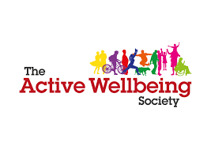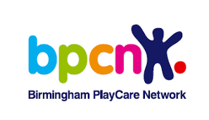If you would like support to register places on the programme, your holiday club, local youth services, children’s centres and libraries can help you.