FREE SCHOOL MEALS  Application Form | 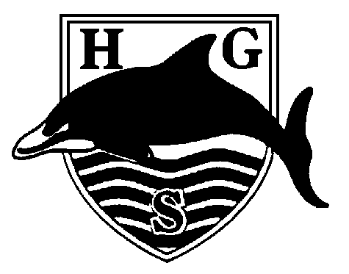

Pupil Name: Form:

You will qualify for free school meals if you or your partner are receiving:-
- Income Support (IS);
- Income Based Jobseekers Allowance (IBJSA);
- Income Based Employment abd Support Allowance (ESA)
- Support under part VI of the Immigration and Asylum Act 1999.
- Child Tax Credit, provided you do NOT get Working Tax Credit and have an annual income that does not exceed £16,190.
- Universal Credit – If you apply on or after 1 April 2018 your household income must be less than £7,400 per year(after tax and not including any benefits you get
- Guaranteed element of State Pension Credit.
**Please note you do NOT qualify for Free School Meals if you are in
receipt of Working Tax Credit regardless of your income.**
To apply please complete and return this form to the school office along with proof that you are entitled to any of the above and it must be dated within the last 6 months.
School
Your address
Postcode |  |  |  |  |  | Contact Tel No
You and Your Partner
Title |  | Mr Mrs Ms Miss |  |  |  |  |  | Mr Mrs Ms Miss
Surname/Family Name
Other Names
Date of Birth
   |  | / |  |  | /
   |  | / |  |  | /
National Insurance Number
Do you or your partner receive Income Support (IS), Job Seekers Allowance (JSA) or Income Related Employment and Support Allowance ( ESA) |  |  |  | Yes |  |  |  | No - you cannot get free meals
Child Tax Credit with NO working tax credit element and a gross income of no more than £16,190pa |  |  |  | Yes |  |  |  | No - you cannot get free meals
Universal Credit and your household net income is less than £7,400 pa (not inc benefits) |  |  |  | Yes |  |  |  | No - you cannot get free meals
Support under Part VI of the Immigration and Asylum Act 1999 |  |  |  | Yes |  |  |  | No - you cannot get free meals
Guaranteed element of State Pension Credit |  |  |  | Yes |  |  |  | No - you cannot get free meals
APPLICATION FOR FREE SCHOOL MEALS (continued)
Children living with you who go to school
Full Name |  |  | Sex |  | Date of Birth |  | School

I wish to claim free meals from
   |  | / |  |  | /
Declaration: If you give false information you could be prosecuted
- As far as I know the information I have given is complete.
- I agree that you may make any enquiries to check the information I have given.
- I will tell you at once if my circumstances, income or savings change.
- I will tell you at once if there is any change in the circumstances or income of the people living in my house.
Your signature: |  | Date:
This documentation is treated in accordance with
the General Data Protection Regulation (GDPR) (EU)2016/679

