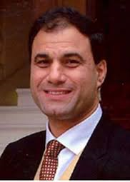

**Business Studies: Can you match the images the famous entrepreneurs to the names provided below?**

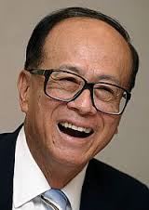

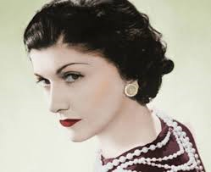



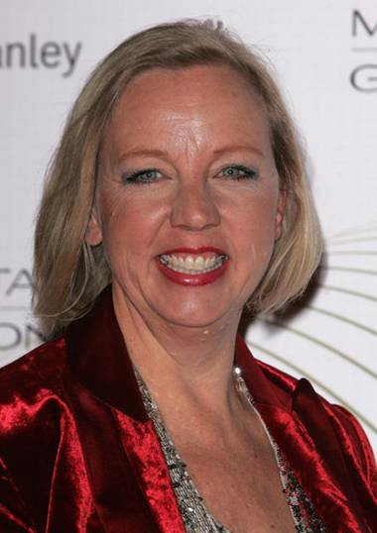

Karan Bilimoria

Levi Roots

Deborah Meaden

Bill Gates

Coco Chanel

Steve Jobs

Li Ka Shing