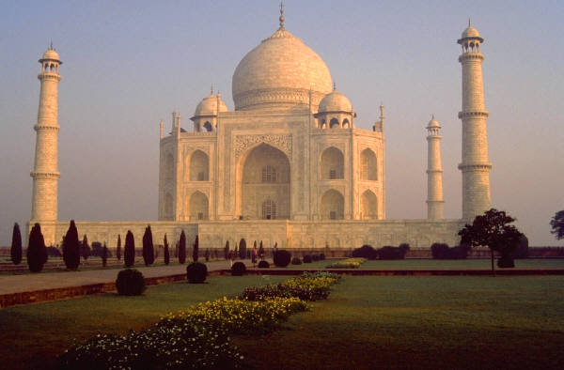
5 Places to Visit in Your Lifetime…

Aims and objectives of the Task

- To produce a piece of work about 5 different places you would love to visit in the world

The Task

If you had to choose 5 places to go in the world, where would you pick?

Travel writer Steve Davey wrote a book in 2004 called ‘Unforgettable Places to See before You Die’ in which he selected 40 of his most favourite places he thought people should see in their lifetime.
You now need to choose 5 places which you would love to go to. They may be beautiful or awe-inspiring, dangerous or extreme - it’s your choice!

You may present your work however you like, but here are some instructions about what you need to do:

- Identify 5 places in the world that you want to visit. You may have been to some of them before, or you may have seen them on TV, in books, on the internet, etc.

- Include a map of the world. Accurately mark and label on the map the places you have chosen to visit.

- Write a description of the places that you have chosen to visit in your own words and explain why you have chosen to visit each place.

- Finally, find some images and photos of the places you have chosen and include these, labelling what they show.

- Below are a couple of websites to give you some inspiration, but of course you can just use a search engine like Google for ideas.
- https://www.lonelyplanet.com/best-in-travel
- https://www.forbes.com/sites/laurabegleybloom/2019/09/04/bucket-list-travel-the-top-50-places-in-the-world/

- Remember:
- Think carefully about how you are going to present your work, and use your own words to describe each place – copying and pasting is not allowed!
- You can ask someone (e.g. a parent) for help in deciding which places to choose and how to research the information but the finished piece must be your own work.
- You could present your work as a leaflet, poster, fact file, news article or as a PowerPoint presentation just to give you a few ideas.

