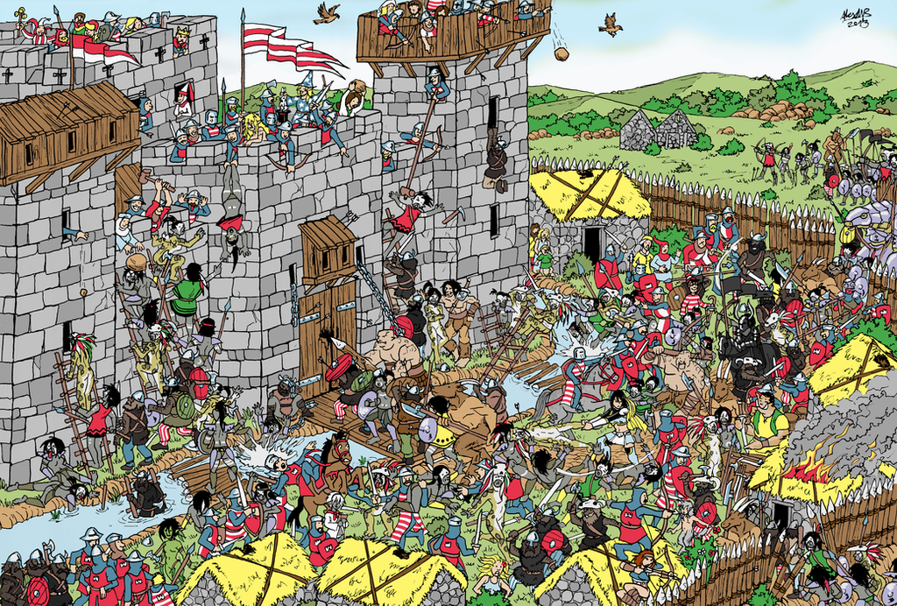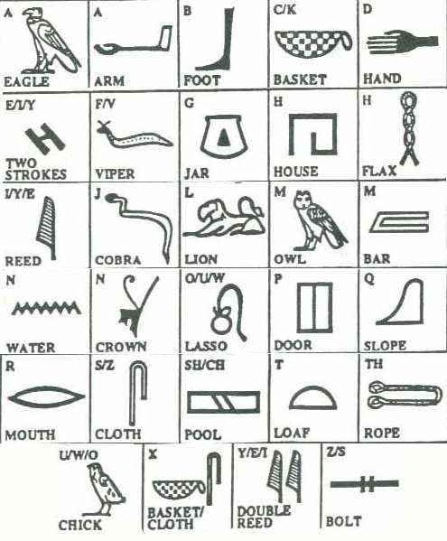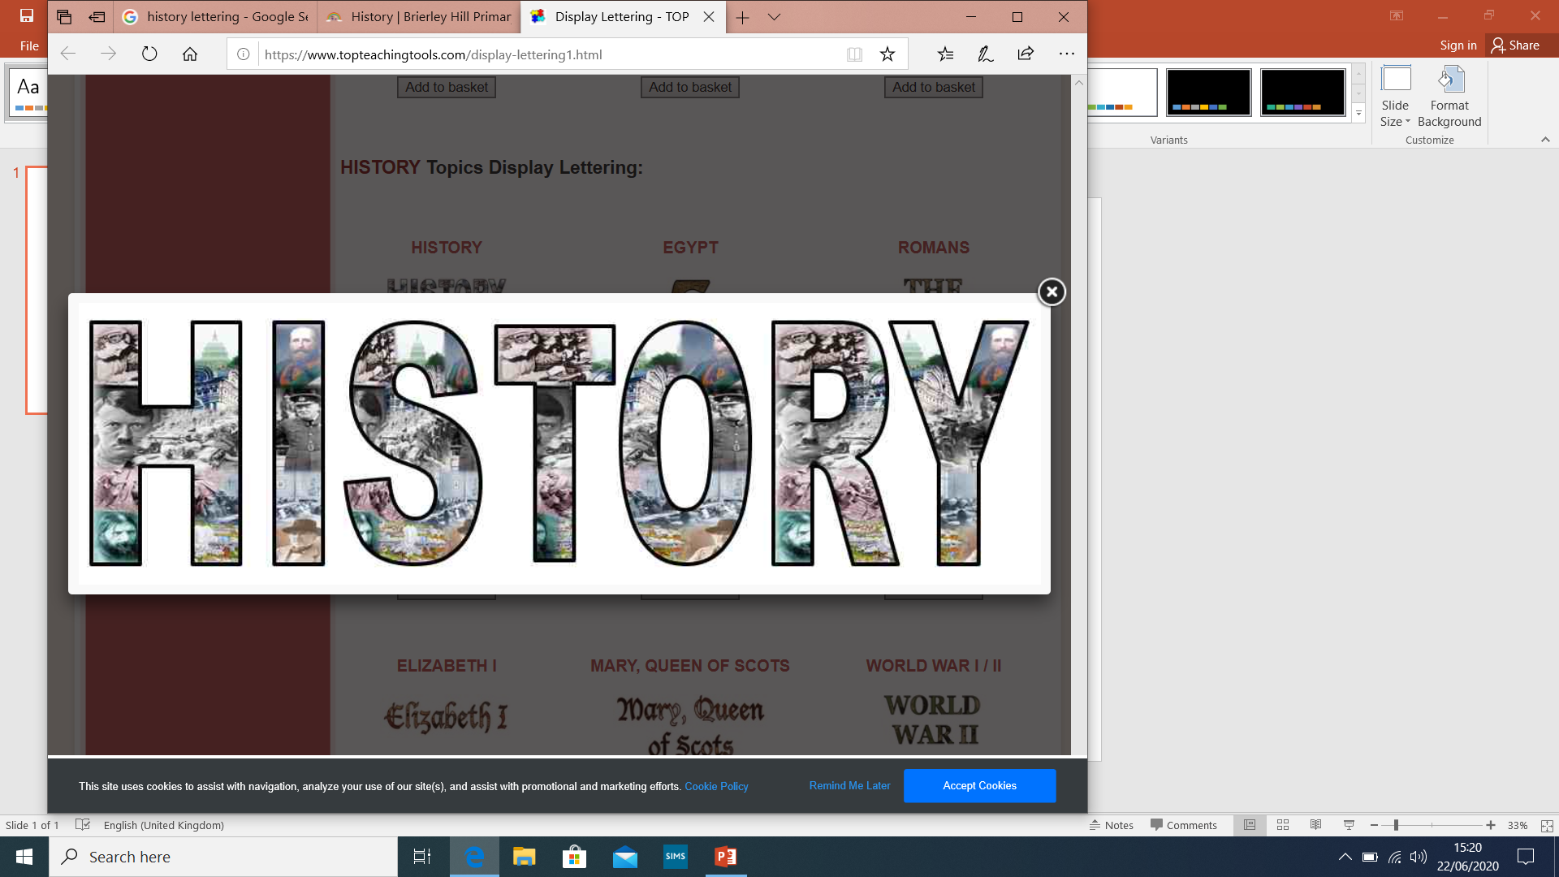

Where’s Wally? Can you find him hiding in this castle scene?

**History Jokes!**

Q; In which battle did solders form a queue for the toilet? A: The Battle of Portaloo.

Q: Which famous Roman suffered from hayfever? A: Julius Sneezer.

Q: Who invented fractions? A: Henry 1/8th

Q: What is the fruitiest school subject? A: History, because it is full of dates!

Riddle Answer: History!

Riddle: You will always find me in the past. I can be created in the present but the future can never taint me. What am I?

Can you write your name in hieroglyphics?

Perhaps you could write something and get someone to decipher it?

Riddle Answer: History!

Can you find your way out of the Colosseum? Start at the S and end at the E.