Hall Green School – Music

Activity 1 – Instruments of the Orchestra Quiz

If it is possible, please watch the following YouTube video;
https://www.youtube.com/watch?v=gGDh3_l55ug
While watching and listening to the video, write down the name of the instrument that you hear in the table below. (Use the pictures and names in the video to help you). Check your answers below.
# | Instrument | # | Instrument | # | Instrument
1 |  | 6 |  | 11
2 |  | 7 |  | 12
3 |  | 8 |  | 13
4 |  | 9 |  | 14
5 |  | 10 |  | 15

Activity 2 – Drawing Musical Notes Activity 3 – Draw a Treble Clef (As neatly as you can)

Copy the Treble Clef four times in the empty boxes
- Draw a ONE BEAT note:
………………
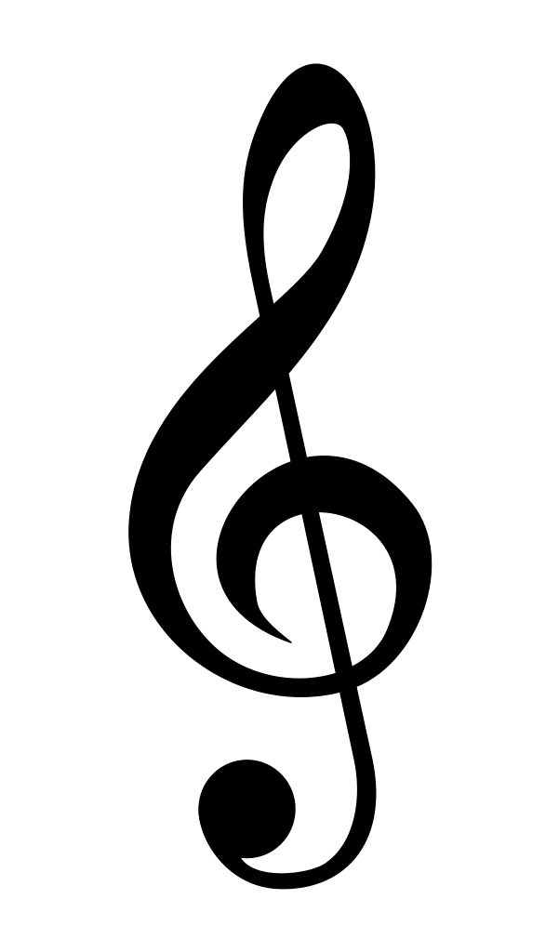Treble Clef
- Draw a TWO BEAT note:
………………
- Draw a THREE BEAT note:

………………
- Draw a FOUR BEAT note:
………………
- Draw 2 HALF BEAT notes:
………………
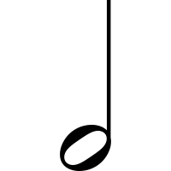
Activity 4 - Trace and shade in the notes on the keyboard.
One Beat
Note
Two Beat
Note
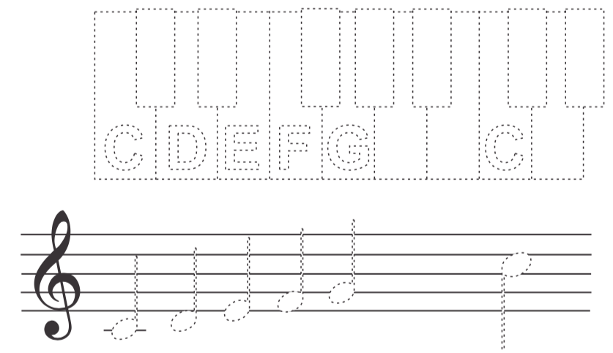

Four Beat
Note

Answers: 1) Flute 2) Piccolo 3) Trumpet 4) Cello 5) Bass Drum 6) Timpani 7) Clarinet 8) Oboe 9) Glockenspiel 10) Violin
11) Double Bass 12) Glockenspiel 13) Trombone 14) Snare Drum 15) Tuba
2 Half Beat
notes
Three Beat
Note

