Religious Education Quiz
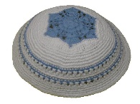
- What is the name of this hat?

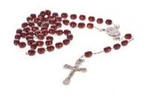
- What is the name of this item?

- How many pillars are there in Islam?

- What is the name of the Sikh holy Book?
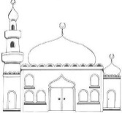
- What is the name of the tall tower of a mosque called?

- What is the name of a Jewish place of worship?
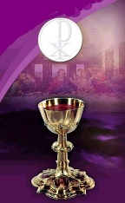

- Which religion does the following items belong to?

- Which religion does Siddharta Gotoma belong to?
Answers
- Kippa
- Roasary Beads
- Five
- Guru Granth Sahib
- Minaret
- Synagogue
- Christianity
- Buddhism
- Muhammad (pbuh)
- Ganesh
- What is the name of the final prophet believed by Muslims?

- What is the name of the elephant God in Hindusim?

