**Energy Resources Booklet**

**To be completed week beginning 4th May**

This booklet covers:

1. Energy from the Sun
2. Energy from fossil fuels
3. Energy from moving water
4. More renewable resources
5. 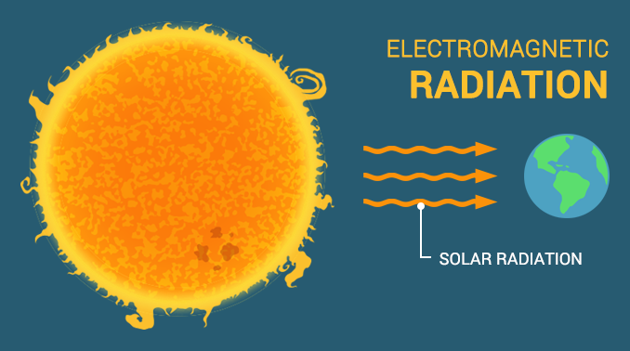**Energy from the Sun**

The heat from the sun is known as infrared radiation. Infra-red radiation is also responsible for the heat that we feel when we are beside a fire or that turns bread into toast in a toaster. Light is another way the energy from the sun can reach us. These are forms of electromagnetic radiation.

This energy from the Sun is important for all life on our planet. It is used by plants to make their own food, which then provide all the energy for all other living organisms.

When these living organisms die, the energy they have stored inside them is not lost. They are either recycled by other living organisms, or can be turned into fossil fuels.

**What are fossil fuels?**

There are 3 main types of fossil fuels – coal, oil and natural gas – and they are all made from organisms that died millions of years ago.

**So how are fossil fuels made?**

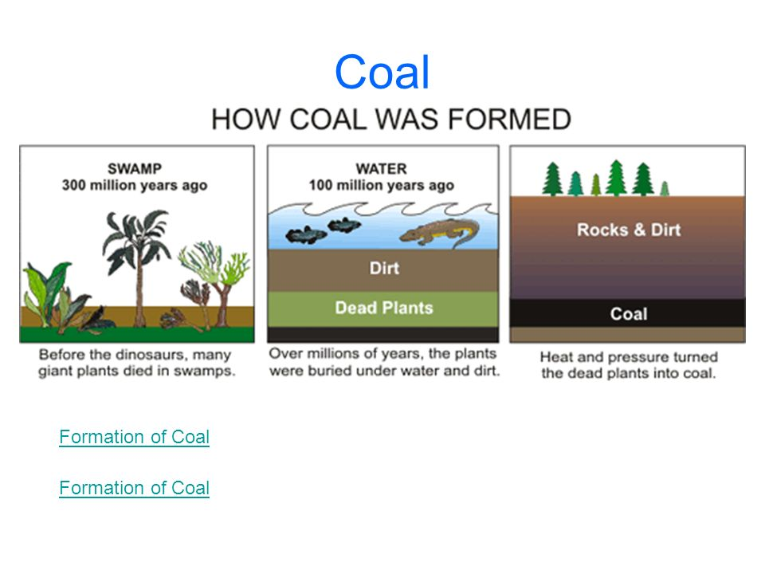They all follow the same sequence of events. The organisms die, they are covered by dirt, rocks or water and then over millions of years they are buried. As the remains get pushed further and further underground they get put under lots of pressure from the ground above them and heated up from the hot rocks underneath them. Over time, the dead remains become fossil fuels.

**What is the difference between the different fossil fuels?** It is all about the organisms they were made from.

* Dead sea plants become natural gas.
* Dead sea animals become oil.
* Plants on land become coal.

**Questions:**

1. Name two types of electromagnetic radiation that are given off by the Sun.
2. Why is it correct to say the energy from fossil fuels comes from the Sun?
3. What two things are needed to turn dead organisms into fossil fuels?
4. Why are there different types of fossil fuel?
5. **Energy from fossil fuels**

An **energy resource** is something that stores energy in a form that can be easily used. **Fossil fuels** and **biomass** are energy resources. Biomass is the scientific term for the energy stored in living organisms that can be cut down and burned, usually trees and plants.

We can use their chemical stores to heat buildings, drive engines or generate electricity.

**How do they generate electricity?** They all rely on the same idea – they can be burned in power stations and the energy that is released can be used to turn water into steam. That steam is then collected and pushed towards a turbine (something that looks like a giant fan) which makes it turn. The turbine is connected to a generator, so as the turbine turns it powers the generator to make electricity. This is then sent around the country by giant cables in a system called the National Grid.

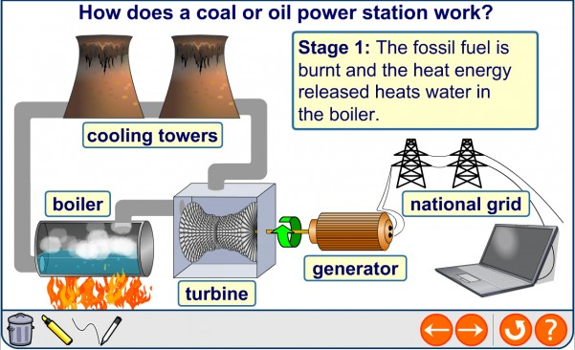

Fossil fuel e.g. coal

The steam turns the turbines and is then cooled back into water in cooling towers so it can be used again and again

Natural gas is the most efficient fossil fuel to use because it can make two turbines turn, not just one. One turbine is powered by steam, like all the other fuels, and the second is powered by the waste gases that are given off when the gas is burned.

**Are fossil fuels good or bad?**

Fossil fuels cause environmental problems such as acid rain and global warming and they are running out too. They take millions of years to produce and we are using them up much quicker than they are made. This means we call them non-renewable energy resources.

**So why do we still use them?** They produce a huge amount of energy and they are reliable (can be used day or night and why understand how they work). Some renewable resources like solar panels or wind farms are not yet this reliable. We also have lots of power stations already made and it will be expensive to replace them with new, renewable ones.

Some power stations burn wood from forests of fast growing trees (known as biomass). These work in the same way as the ones that run on coal – can you remember how? Burning wood can release carbon dioxide into the atmosphere – but the next generation of trees absorbs it again in photosynthesis – this is known as carbon neutral.

**What about nuclear power stations?**

Nuclear fuels are not fossil fuels but will run out at the same time. Nuclear power stations do not produce carbon dioxide, which is good. However, radioactive waste is harmful and needs to be stored safely because it remains radioactive for 1000’s of years.

**Questions:**

1. What is biomass?
2. How do fossil fuels make a turbine turn in a power station?
3. Give one advantage and one disadvantage of using fossil fuels to make electricity.
4. Why are natural gas power stations more efficient than other types of power station?
5. What does carbon neutral mean and why is Biomass carbon neutral?
6. **Energy from moving water**

Moving water contains lots of energy. There are lots of places around the world where there is moving water – streams, waterfalls, rivers and oceans all contain lots of moving water. The energy from this moving water can be used to create electricity, without the pollution that is made from power stations that burn fossil fuels.

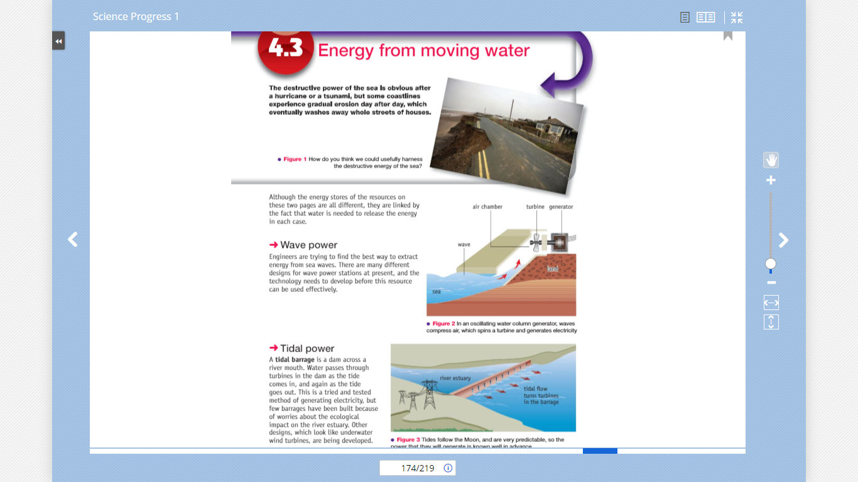There are several different ways we try this:

**Wave power**

Waves can be used to directly make a turbine turn as the wave moves in and out. As the turbine turns, it powers the generator to make electricity. These types of power station are still be developed by engineers.

**Tidal power**

A big barrier called a barrage is built across a river. As the tide moves in and out it turns the turbines which power generators to make electricity. These have been used for a long time, but they are not used in many rivers because there are concerns the barrages may harm the fish and plants that live in rivers.

**Hydroelectric power**

Hydroelectric power (HEP) uses energy from falling water in waterfalls to drive turbines. These power stations do not produce carbon dioxide and the resource will never run out – it is renewable. However, the large dams needed to create the waterfalls can flood habitats for people and wildlife.

**Pumped storage**

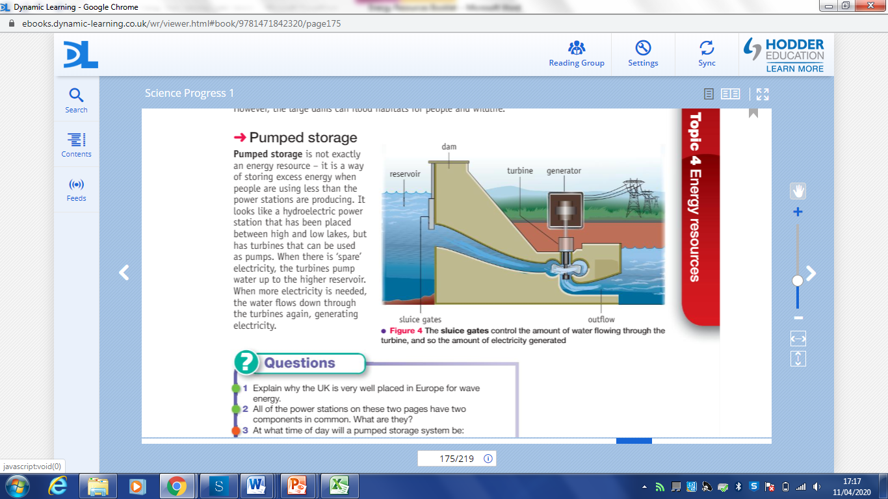Pumped storage is not really an energy resource, it’s a way of storing excess energy when people are using less than the power stations re producing. It looks like a hydroelectric power station that has been placed between high and low lakes, but has turbines that can be used as pumps. When there is ‘spare’ electricity, the turbines pump water up to the higher reservoir. When more electricity is needed, the water flows down through the turbines again, generating electricity.

**Questions:**

1. What do wave power, tidal power, hydroelectric power and pumped storage all have in common?
2. Where would you build a tidal power station?
3. What is the disadvantage of hydroelectric power stations?
4. Why are all these energy resources better than fossil fuel power stations?
5. **More renewable energy resources**

There are many other types of renewable energy resources that do not use water. The 3 we are going to learn about are solar, wind and geothermal.

**Solar:**

Solar energy can be used in two different ways. Solar cells (also called photovoltaic cells) convert sunlight directly into electricity. The radiation from the Sun can also be used to directly heat water for houses so they don’t have to use their boiler as much. This can work during winter as well as summer (but it is more effective in summer or sunny countries).

|  |  |
| --- | --- |
| **Advantages** | **Disadvantages** |
| Renewable | Unreliable – needs sunshine to be most effective |
| Doesn’t cause acid rain or global warming | Can’t run at night |
| Cheap to run once built | Expensive to build |
|  | Uses toxic chemicals to build |

**Wind:**

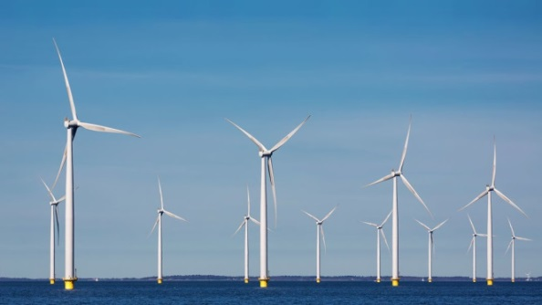Wind energy is renewable and does not produce carbon dioxide. It is not as expensive as solar power. Wind farms of many wind turbines take up a lot of space and can be noisy close up. To solve these problems, some companies are now placing wind turbines offshore (out at sea). You need lots of wind farms to make it reliable because it will always be windy somewhere.

|  |  |
| --- | --- |
| **Advantages** | **Disadvantages** |
| Renewable | Unreliable – needs to be windy to work |
| Doesn’t cause acid rain or global warming | Noisy and can spoil natural beauty spots |
| Cheap to run once built | Expensive to build |
|  | Large area required to build a whole ‘farm’ |

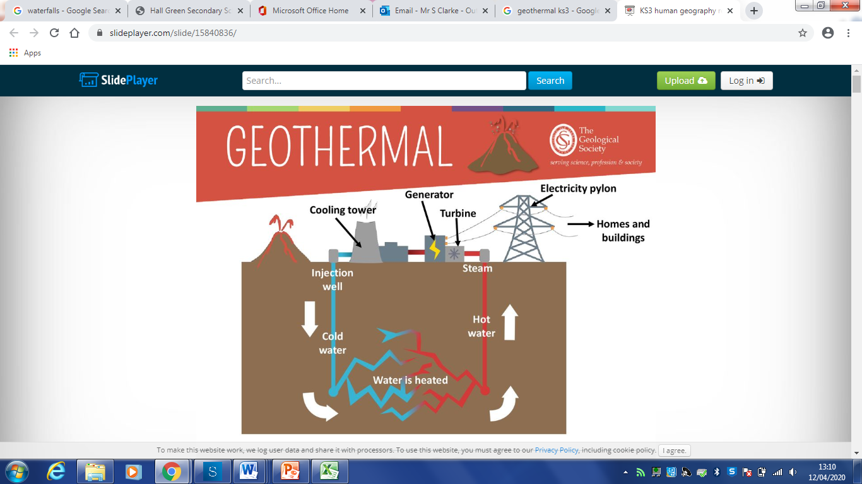**Geothermal:**

In Geothermal power stations hot underground rocks turn from water into steam to drive turbines and generate electricity. The heat rises from deep in the Earth’s crust and is renewable, but there are only certain places on Earth that have a suitable geology.

|  |  |
| --- | --- |
| **Advantages** | **Disadvantages** |
| Renewable | Only works in certain areas |
| Doesn’t cause acid rain or global warming | Expensive to build |
| Requires little energy or cost to run once built |  |

**Questions:**

1. Solar energy can be used to make electricity by using what piece of equipment?
2. Apart from making electricity, what else can solar energy be used for?
3. What is an offshore wind farm and why are they being built?
4. What does a geothermal power station rely on to turn water into steam?

**Answers:**

1. Visible light and infra-red.
2. Fossil fuels are made from dead plants and or animals. Animals need plants for food and plants get their energy to live from the Sun.
3. Heat and pressure (and a long period of time).
4. It depends what organism died and where it died. Coal – plants on land; natural gas – plants under the sea; oil – animals under the sea.
5. Energy stored in living organisms (usually plants and trees).
6. They are burned to release heat energy which turns water into steam. The steam makes the turbines turn.
7. Advantages – produce a lot of energy/electricity; they are reliable.

Disadvantages – cause pollution/global warming/acid rain; they are non-renewable.

1. They can turn two turbines at the same time.
2. It means the same amount of carbon is absorbed into plants as is given off during burning. Biomass is carbon neutral because all the carbon dioxide given off when the trees are burned is absorbed back to make the next generation of trees.
3. Use the energy in moving water to make electricity.
4. In a (large) river.
5. They need dams to be built which flood habitats that people or wildlife live in.
6. They don’t give off carbon dioxide and they will not run out.
7. Solar cell / photovoltaic cell
8. To heat up water in houses.
9. It is lots of wind turbines built out at sea. It is done because wind farms can take up lots of space and be noisy, so people don’t want them near their houses.
10. The heat released from hot rocks deep underground.