**Food and digestion booklet**

**To be completed week beginning 20th April**

**This booklet covers:**

**1. Healthy eating**

**2. Food tests**

**3. Digestive system.**

**4. Poor diet and cancer.**

**1. Healthy eating**

Humans need to consume a balanced diet which contains a variety of different types of food.

The main nutrients the body needs are:

* + **carbohydrates** for energy.
  + **proteins** for growth and repair.
  + **fats** to store energy.
  + **vitamins** and **minerals** to keep the body healthy.
  + **Fibre** and **water**
* 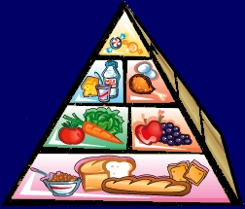The amount of each food type needed is related to the proportions in the food pyramid.

**Water**

Around 70% of your body mass is water. Chemical reactions in cells take place in water and the blood transports substances dissolved in water.

You need to frequently drink water to replace the water lost in urine, sweat and breathing out.

**How much?**

It is important to eat nutrients in the correct amounts – too much may cause obesity and too little may cause malnutrition.

The World Health Organisation recommends getting at least half of your energy intake from carbohydrates and no more than 30% from fats. The organisation also recommends 400 g of fruit and vegetables daily.

**Questions**

1) Name the seven types of nutrients needed in the body.

2) What would happen if you ate too much food?

3) What are carbohydrates needed for?

4) What are proteins needed for?

5) Why do children and babies need more protein?

**2. Food tests**

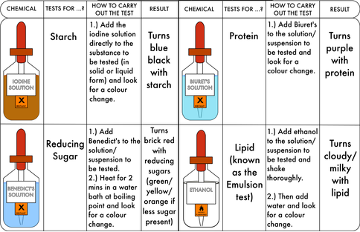We can test food, to determine what food group they belong in.

1.) complete the table using the above information.

|  |  |  |  |  |
| --- | --- | --- | --- | --- |
| **Food sample** | **Test** | **Solution used in the test** | **Observation** | **Food Group** |
| Pasta |  |  |  |  |
| Chicken |  |  |  |  |
| Potato |  |  |  |  |
| Fizzy drink |  |  |  |  |
| Oil |  |  |  |  |

2.) Complete the following sentences.

Starch is tested using:

Fat is tested using:

Protein is tested using:

Sugar is tested using:

3.) Suggest why it is important to carry out food tests.

**3. Digestive system**

* The functions of the digestive system are to digest and absorb foods.
* Digestion is the breakdown of large, insoluble foods into smaller, soluble ones.
* These can then be absorbed into the bloodstream.

**How is food broken down:**

* Food is physically broken down by chewing food in the mouth, using the teeth.
* The pieces of food are then small enough to be swallowed.
* More physical digestion happens when food is churned in the stomach.
* Chemicals called enzymes are added to the food in the mouth, stomach and small intestine.

**What are enzymes?**

* Biological catalysts that speed up chemical reactions.
* The enzymes in the digestive system speed up the breakdown of starch, proteins and fats, which are too large to be absorbed through the wall of the small intestine into the blood.

**Organs in the digestive system:**

* **Mouth** – food is chewed and saliva is added from the salivary glands. Saliva contains enzymes
* **Oesophagus** – a muscular tube that pushes food into the stomach.
* **Stomach** – a muscular bag that churns food with digestive juices. The juices contain hydrochloric acid to kill bacteria and enzymes to digest food.
* **Pancreas** – produces enzymes that are released into the small intestine.
* **Large intestine** – Water is absorbed into the blood
* **Small intestine** – Digestion is complete -useful products are absorbed into the bloodstream
* **Rectum** – Undigested foods (faeces) are stored here
* **Anus** – faeces are passed out of the body when you go to the toilet.

**Questions:**

1.What is the role of the digestive system?

2. Explain how food is broken down.

3. Explain the function of enzymes.

**4. Poor diet and cancer**

# **Effects of a poor diet**

A balanced diet is one that contains the correct amounts of all the necessary nutrients needed for healthy growth and activity. An imbalanced or poor diet can contain too much or too little of a nutrient. If you have too little of a nutrient, we say that you have a deficiency in that nutrient. For example, fibre is needed to keep food moving through the intestines easily, and people who have a fibre deficiency in their diet may get constipation.

## Mineral deficiencies

You only need small amounts of the different minerals in your diet to stay healthy, but mineral deficiencies can make you ill. For example:

* iron deficiency can cause anaemia, where there are too few red blood cells
* iodine deficiency can cause a swelling in the neck called goitre

## 

Goitre, a neck swelling caused by iodine deficiency.

**Vitamin deficiencies**

Like minerals, you only need small amounts of the different vitamins in your diet to stay healthy, but you become ill if you do not get enough. For example:

* 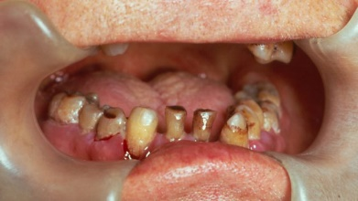vitamin A deficiency can cause blindness
* vitamin C deficiency causes scurvy, which makes the gums bleed
* vitamin D deficiency causes rickets, which makes the legs bow outwards in growing children

**Cancer and processed foods**

Watch the following video and write down three key points about the link between cancer and processes food.

* <https://www.youtube.com/watch?v=OoHaC7vnCyA>

**Questions:**

1. Describe some of the effects of a poor diet.

2. Explain what iron deficiency can cause.

3. Explain what happens when there is a lack of vitamin C.

4. Use google to research the diseases in the table below and complete the table, some of the information is already in the booklet.

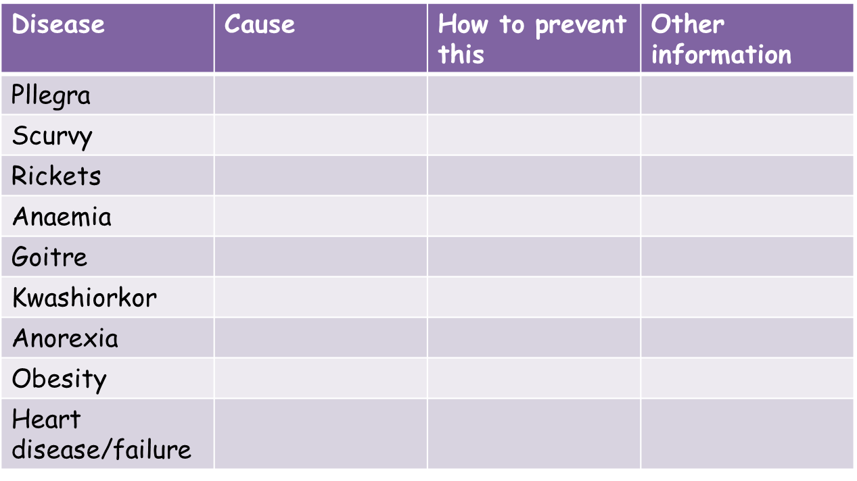

**Answers:**

**Healthy eating**

1. Carbohydrates, protein, fats, fibre , water, minerals and vitamins.

2. If you eat too much food, you can gain weight and this can make you overweight.

3. They provide you with energy for your daily tasks.

4. Proteins help repair cells and make new cells.

5. Children and babies will need more protein, as they are growing and developing.

**Food testing**

1. The table should have been completed using the information given in the booklet.

2.

Starch is tested using: iodine solution

Fat is tested using: ethanol

Protein is tested using: biuret solution

Sugar is tested using: benedict’s solution

3. It is important to test food, so that we can determine what food group it belongs in and can give correct information to people buying food.

**Digestive system**

1. The digestive system breaks down and absorbs food.

2. Food is chewed and made smaller so it can be swallowed. More physical digestion happens when food is churned in the stomach. Chemicals called enzymes are added to the food in the mouth, stomach and small intestine.

3. Biological catalysts that speed up chemical reactions.

**Poor diet and cancer**

1. A poor diet can cause deficiency, heart problems and cancer.

2. Iron deficiency can cause anaemia, where there are too few red blood cells

3. Vitamin C deficiency causes scurvy, which makes the gums bleed