**Magnets and Electromagnets Booklet**

This booklet covers:

·1. Magnetism ·

2. Magnetic fields

3. Electromagnetism

4. More electromagnets

1. **Magnetism**

Magnetism is a non-contact force that affects magnetic materials within a magnetic field. Magnetic material can be magnetised or will be attracted to a magnet.

Most materials are not magnetic, but some are. These metals are magnetic:

|  |  |  |  |
| --- | --- | --- | --- |
| **Iron** | **Steel** | **Cobalt** | **Nickel** |

A bar magnet is a permanent magnet. This means that its magnetism is there all the time and cannot be turned on or off. A bar magnet has two magnetic poles:

* north pole (or north-seeking pole)
* south pole (or south-seeking pole)

The north pole is normally shown as N and the south pole as S

**Attract and repel**

If you bring two bar magnets together, there are two things that can happen, attraction and repulsion:

* if you bring a north pole and a south pole together, they attract and the magnets stick together
* if you bring two north poles together, or two south poles together, they repel and the magnets push each other away

We say that opposite poles attract, and like poles repel.

**The compass**

A compass is made of:

* a magnetic needle mounted on a pivot (so it can turn freely)
* a dial to show the direction

The north pole (north-seeking pole) of the compass needle points towards the Earth’s North Pole. If the needle points to the N on the dial, you know that the compass is pointing north. This lets you navigate outdoors using a map.

Geographical North attracts the north pole of a magnet, so for this reason what we call the North Pole must be a magnetic south pole.

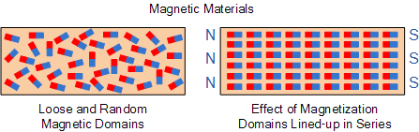Magnetic materials contain tiny areas known as **magnetic domains**; they are like tiny magnets within the material. In a magnet the domains are all lined up in the same direction, in unmagnetized material they all face in different directions

Magnetic material becomes an ‘**induced magnet**’, when placed inside a magnetic field. If a piece of iron is connected to a magnet then paperclips can be attracted to the iron, however the paperclips fall from the iron if the magnetic is removed. An induced magnet is only magnetic when inside a magnetic field.

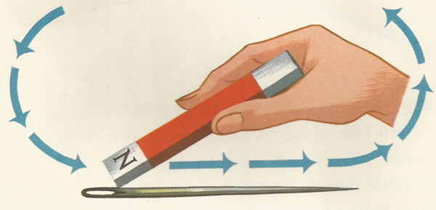**Making a magnet**

In an induced magnet, when the magnetic material is moved away from a magnet the domains return to a random state. It is possible to make a more permanent magnet by repeatedly rubbing a piece of magnetic material, in the same direction, with a strong magnet. Materials that remain magnetised for long periods of time are known as hard magnetic materials. Materials that are quick to lose their magentism are known as soft magnetic materials.

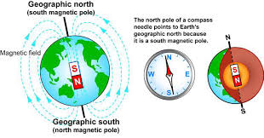**The Earth’s magnetism**

The Earth’s core contains molten iron and nickel, this produces a giant magnetic field surrounding the Earth. The Earth behaves as if it contains a giant magnet. It produces a magnetic field in which the field lines are most concentrated at the poles. This magnetic field can be detected using magnetic materials or magnets.

The Earth’s magnetic field affects the needles in compasses.

Questions:

1. What is the difference between a magnet and a magnetic material?
2. Can you make a magnet with just one pole? Explain
3. Two pieces of iron attract each other. How can you tell whether they are both magnets?
4. What happens to the domains of an un-magnetised piece of steel when it is magnetised?
5. **Magnetic fields**

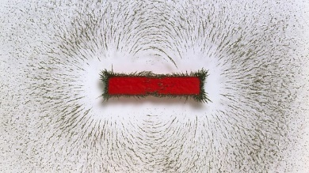A magnet creates a magnetic field around it. You cannot see a magnetic field, but you can observe its effects.

You can use a plotting compass or iron filings to detect a **magnetic field**:

1. put a piece of paper over a magnet (this stops the iron filings sticking to the magnet)
2. sprinkle iron filings onto the paper
3. gently tap the paper to spread the filings out
4. observe and record the results

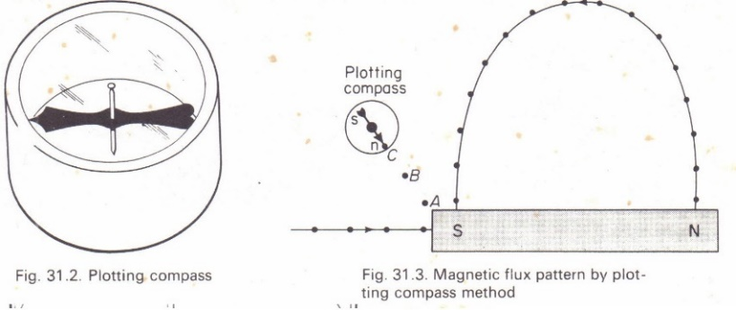Iron filings show the magnetic field around this bar magnet

It would be difficult to draw the results from the sort of experiment seen in the photograph, so we use a plotting compass to draw simple **magnetic field lines** instead.

1. Place the magnet in the centre of a sheet of plain paper.
2. Place the plotting compass close to the magnet.
3. Use a pencil to draw a dot where the compass points.
4. Move the compass so that the back of the arrows is facing the dot and draw a fresh dot where the arrow is pointing.
5. Repeat this until you return to the magnet.
6. Repeat 2-5 for additional field lines

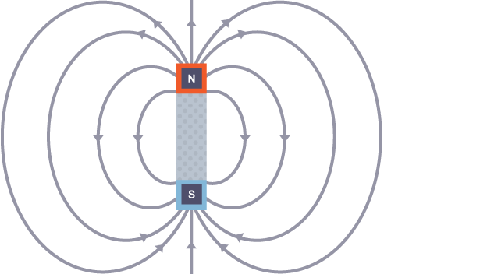In the diagram, note that:

* each field line has an arrow on it
* the arrows show the field lines coming out of the north pole and going into the south pole
* the field lines are more concentrated at the poles

The magnetic field is **strongest** at **the poles**, where the field lines are most **concentrated**.

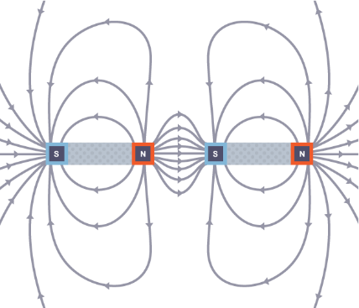Field lines also show what happens to the magnetic fields of two magnets during attraction or repulsion.

Field lines lead from one magnet to the other when the magnets attract each other.

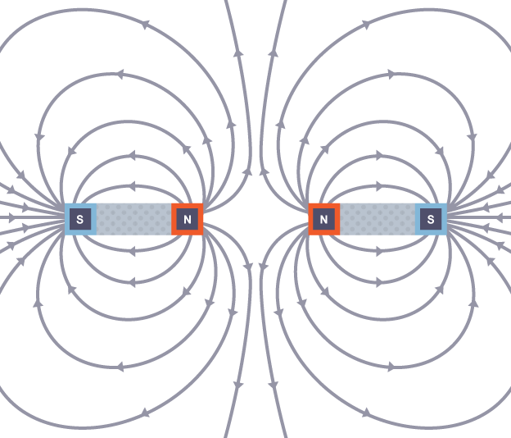

Field lines do not lead from one magnet to the other when the magnets repel each other. →

Permanent or temporary?

* Iron = soft magnetic material. This means it can be turned into a magnet, but it will not last forever. It is a temporary magnet.
* Steel = hard magnetic material. This means it can be permanently turned into a magnet.
* Iron can be temporary and steel can be permanent as iron loses its magnetic field quicker.

Questions:

1. What direction does the magnetic field lines always point?
2. What pattern do the magnetic field lines fall into?
3. How can you tell where the magnetic field is the strongest?
4. What is the difference between a permanent and a temporary magnet?
5. **Electromagnets**

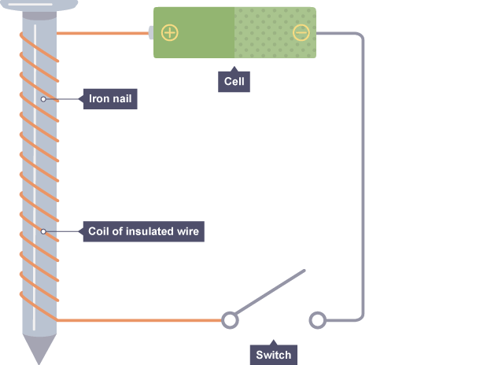**Building an electromagnet.**

* An electromagnet consists of a coil of lots of turns of wire wrapped around an iron core. A coil of wire is called a solenoid.
* When you pass an electric current through the coil, the electromagnet is magnetised.

When electric current flows in a wire, it creates a magnetic field around the wire. This effect can be used to make an electromagnet. A simple electromagnet comprises a length of wire turned into a coil and connected to a battery or power supply.

You can make an electromagnet stronger by doing these things:

* wrapping the coil around a piece of iron (such as an iron nail)
* adding more turns to the coil
* increasing the current flowing through the coil

There is a limit to how much current can be passed safely through the wire because the resistance of the wire causes heating.

Electromagnets have some advantages over permanent magnets. For example:

* they can be turned on and off
* the strength of the magnetic field can be varied

These properties make electromagnets useful for picking up scrap iron and steel in scrapyards. They are also used in MRI scans, electric bells, and particle accelerators.

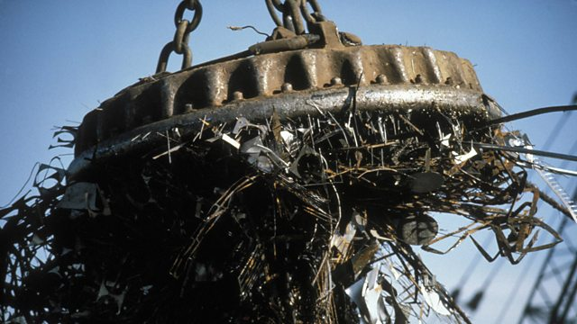

An electromagnet being used in a scrapyard

**The magnetic field of an electromagnet**

The magnetic field around an electromagnet is just the same as the one around a bar magnet. It can, however, be reversed by reversing the current (turning the battery around).

Questions:

1. A crane driver in a scrapyard is trying to pick up a car using an electromagnet to take it to the crusher, but he finds the electromagnet is not strong enough.

a) What can he do to make the electromagnet stronger?

b) How does he release the car when it is above the crusher?

1. An electromagnet in a scrap yard is often build with a U-shaped core. Why is this the case?
2. What is a solenoid?

**4. Uses of electromagnets.**

**Electric bell**



gong

Bell

Iron bar

electromagnet

The electric bell works when electric current is passed through the circuit. This makes the electromagnet have a magnetic field which will then attract the iron bar and make the gong strike the bell.

As this happens there is a gap created in the circuit and so this disconnects the circuit and so the magnet loses its magnetism. This makes the iron bar and so the gong move away which will then connect the circuit again and the whole process starts over unless the switch is opened permanently.

**Loudspeaker**

[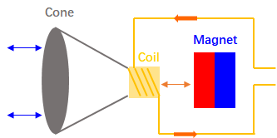](https://www.google.co.uk/url?sa=i&url=https://insightsolutionsglobal.com/how-do-speakers-work-and-how-are-speakers-made/&psig=AOvVaw3gW0j60qStNPgDTEnxi_s8&ust=1586018599327000&source=images&cd=vfe&ved=0CAIQjRxqFwoTCKj2je_ZzOgCFQAAAAAdAAAAABAD)

When the current passes thought eh wire it is an Ac current, this means it keeps changing direction. This makes the electromagnets poles keep changing direction too. So when the north and north are together cone will be repelled and when the north and south are together hey will attract. This makes the cone vibrate backward and forward and so creates a sound.

Questions:

1. What happens to the electromagnet in both things when a current is put though it?
2. How would we turn both things off completely?
3. Put these sentences in the right order to explain how a electric bell works
4. The most common use of electromagnets is in an electric bell.
5. It also pulls the contacts apart.
6. When the bell push is closed, the current flows through the hammer to hit the gong.
7. The process repeats until the bell push is released.
8. This turns the electromagnet off, and so the hammer springs away from the gong, and closes the contact points again, allowing the current to flow once more.
9. The hammer hits the gong again.
10. a) How would the electric bell function if the iron core of the electromagnet was replaced with a steel core?

b) Explain why this happens

**Extension work -** Optional

Create a poster to show how magnets are used in our daily lives, what magnetic fields are and the uses of electromagnetism (give examples).