**Photosynthesis Booklet**

***Keywords list:***

**Photosynthesis**

**Chloroplasts**

**Chlorophyll**

**Glucose**

**Producer**

**Deforestation**

**Global warming**

**Epidermis**

**Guard cell**

**Stomata**

**Fertiliser**

This booklet covers:

1. The importance of plants
2. Photosynthesis
3. Leaf structure
4. Mineral salts and fertilisers­­
5. **+ 2 The importance of Plants + Photosynthesis**

**What is photosynthesis?**

Plants (and algae) make their own food by using light energy. They absorb water (from the soil) and carbon dioxide gas (from the air) and alongside sunlight energy they convert all these into glucose (food) and oxygen. Without sunlight energy the plants cannot carry out photosynthesis.

Photosynthesis can be described using the chemical equation:

**Light Energy**

**Carbon Dioxide + Water Glucose + Oxygen**

**Chlorophyll**

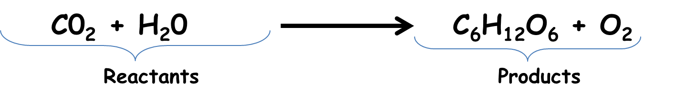

Photosynthesis takes place in the leaf cells inside chloroplasts.

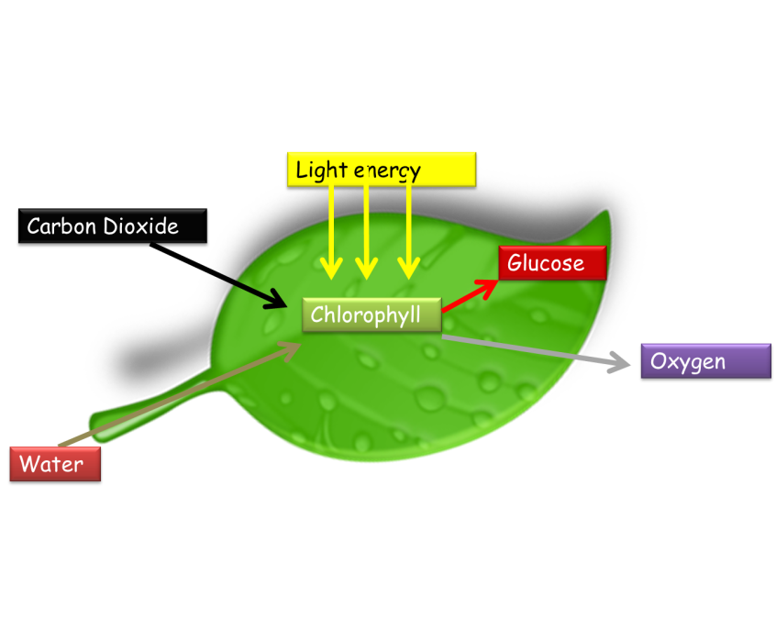The chloroplasts contain a green chemical called ‘chlorophyll’. Chlorophyll absorbs the light energy from the sun and converts the water and carbon dioxide into glucose and oxygen. The diagram below shows the process happening in leaf cells.

Questions:

1. What is photosynthesis and where does it take place?
2. What 3 things are needed for photosynthesis to happen?
3. List the 2 products of photosynthesis.
4. Can you write a symbol equation for photosynthesis? (Hint-look above!)

**Plants as Producers**:

Plants are called producers because they make food (glucose), which provides energy and biomass for other organisms. All organisms need to eat to survive, however plants are producers that make their own food in the chloroplasts of leaves.

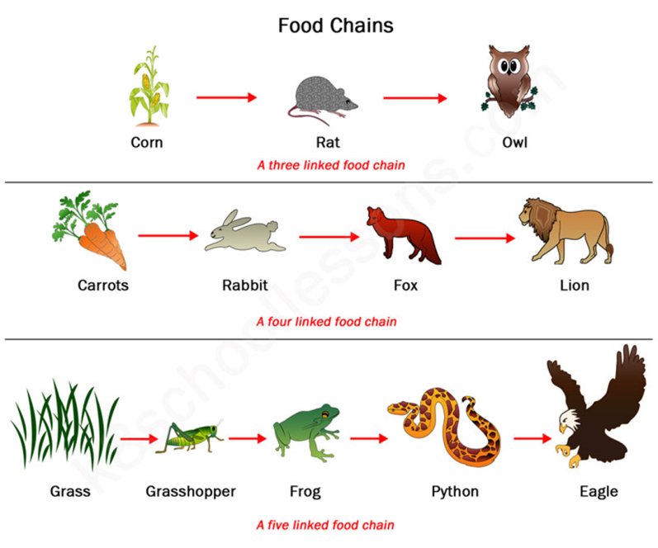Nearly all food chains begin with a plant as a producer

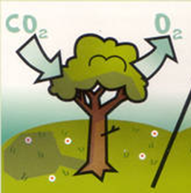**Deforestation:**

* Plants such as trees are very important to life, as they absorb carbon dioxide and release oxygen into the air (during photosynthesis). This maintains the correct balance of carbon dioxide and oxygen in the air.
* *Deforestation* is the process of removing large areas of rainforests to use in making various things (making paper, tables, clearing up woodland for roads and new houses …etc)
* When humans remove large areas of rainforest to build roads and houses, *the oxygen produced is greatly reduced.*
* The habitats around them are also destroyed.
* This can lead to a large increase of carbon dioxide in the atmosphere, which is very worrying as it can cause GLOBAL WARMING.

**Why do we need Plants?**

Plants are needed for many things…

1. Produce the oxygen we need to respire, to supply food.
2. Building, such as trees for timber, and cereal plants for straw to thatch roofs.
3. Fibres used to make clothes, ropes and paper.
4. Chemicals from plants including medicines and biodegradable plastics.
5. Wood is used as a fuel, and also to grow oilseed rape, oil palms and sugarcane to produce fuels.

**Chemosynthesis (deep in the oceans)**

* There are areas in deep oceans where is it is so dark that plants cannot survive (sunlight does not reach these areas and therefore there is no photosynthesis taking place to produce food in the bottom of the ocean)
* However, surprisingly scientists found large communities of different animals living there.
* 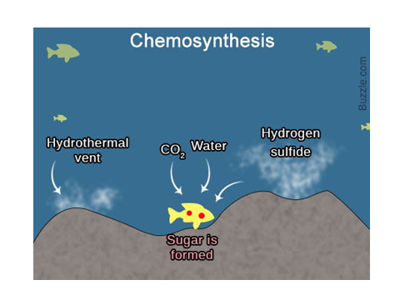The organisms cluster around very hot, acidic springs called *hydrothermal vents.*
* In the hydrothermal vents, bacteria absorb chemicals from the hot water and use them to produce carbohydrates for the rest of the food chain.
* This process is called **chemosynthesis.**
* The bacteria are eaten by animals such as vent limpets, which are eaten by other animals such as vent crabs.

**Questions:**

1. Give four uses we have for plants.
2. Draw a food chain for organisms living near a hydrothermal vent. Include the producer for this food chain. (Hint- look at the above photo)

**3. Leaf Structure** 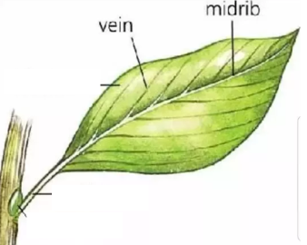

**How are leaves adapted for photosynthesis?**

* Leaves are usually flat and broad so that they have a large surface area to absorb light and carbon dioxide.
* They are very thin so that there is a short distance for carbon dioxide and water vapour to travel to reach the plant cells.
* Water is transported from the roots to the leaves through the midrib and veins.
* Glucose made during photosynthesis is transported from the leaf to the rest of the plant in the veins.

*Copy and complete using the word bank below:*

Leaves are adapted to photosynthesise ____________. Photosynthesis happens in the _________. This is because it contains __________ that takes in the light ________. Leaves are broad, _____ and ______. This is so that they can catch as much ____________ as possible. This makes them similar to a ___________.

**Structure of a Leaf:**

sunlight thin chloroplast flat chlorophyll efficiently solar cell energy

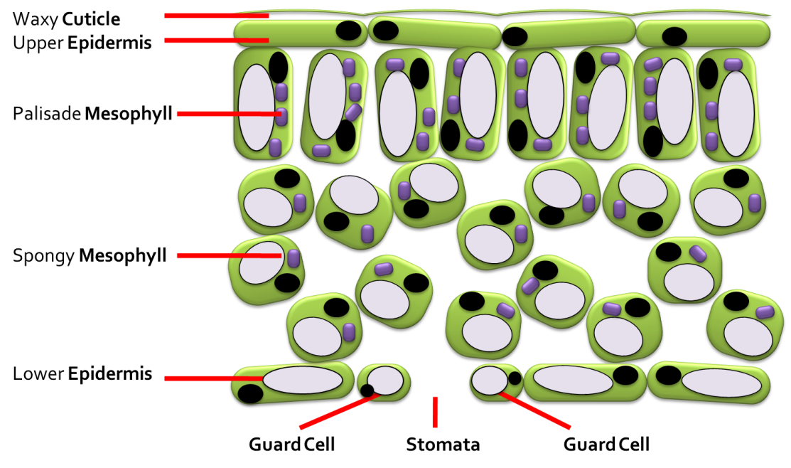

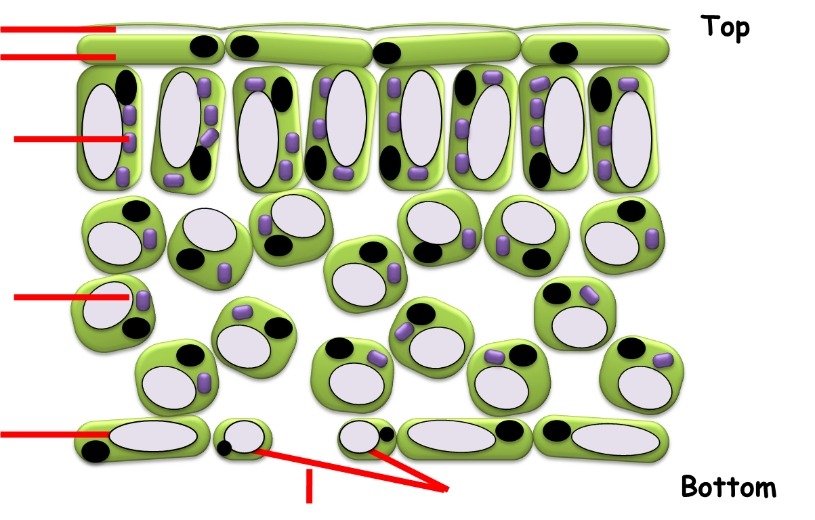**Now you have a go!**

Stomata, Spongy Mesophyll, Waxy Cuticle, Guard Cell, Palisade Mesophyll, epidermal cells

|  |  |
| --- | --- |
| **Leaf part** | **Function** |
| Waxy cuticle | Prevents water loss without blocking out light |
| Upper epidermis | Tightly packed to protect the leaf.  Transparent layer that light passes through to the layers below. |
| Palisade mesophyll | Main photosynthetic layer, contains many chloroplasts. Chloroplasts contain a green pigment called chlorophyll which absorbs as much sunlight as possible. |
| Spongy mesophyll | Contains some chloroplasts.  Has large air spaces between the cells so gases can easily pass to and from the palisade cells. |
| Lower epidermis | Protects underside if leaf. Contains guard cells and stomata |
| Guard cell | They are specialised pairs of cells that have a hole called stomata between them. Guard cells control the size of the stomata.  Contain chloroplasts and can photosynthesise. |
| Stomata | Caron dioxide moves into the leaf and oxygen moves out of the leaf through the stomata |

**Questions**:

1. Why do leaves look green?
2. In which two layers of a leaf does photosynthesis happen?
3. Describe what stomata are, and describe their function
4. Choose 3 parts of a leaf (not stomata) and describe their functions
5. Which scientist interested you the most, and why?
6. **Mineral Salts and Fertilisers:**

**What are Mineral salts and Fertilisers?**

Plants take in water, carbon dioxide and absorb sunlight energy to make glucose and oxygen. However, they would not survive long without small amounts of chemicals called *mineral salts*.

* These mineral salts are dissolved in the water in the soil.
* Plants absorb mineral salts from the soil through their roots.

Fertilisers contain mineral salts that plants need. Gardeners and farmers add fertilisers to the soil to help their flowers or crops to grow.

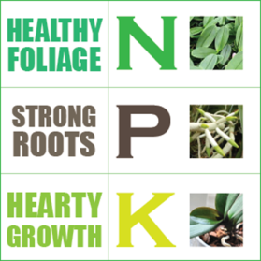Manure (animal dung) is a natural fertiliser, and there are chemical fertilisers.

* Many fertiliser bags have the letters “N P K” on them.
* NPK fertilisers contain three important elements –nitrogen, phosphorus and potassium.

These are letter from the periodic table-do you remember what elements they stand for?

* 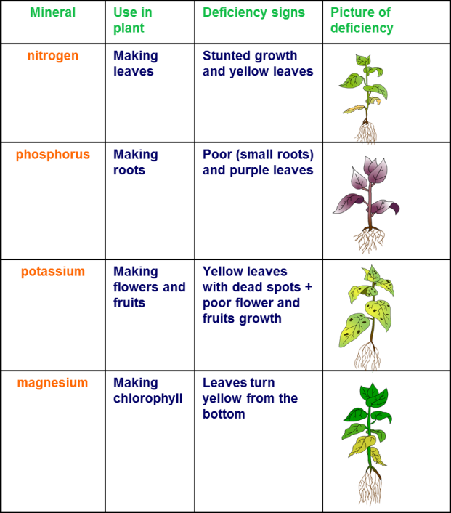N = Nitrogen, making leaves
* P = phosphorus, to make roots
* K=potassium, for making flowers and fruits

There are also other elements like Magnesium which is needed to make chlorophyll.

**Questions**:

1. Why do plants need magnesium?
2. Name the elements that NPK fertilisers contain.
3. A gardener noticed that her plants were not growing well. They were very small with weak stems. Name the element you think these plants were lacking.
4. Describe what hydroponics is.
5. Suggest some advantages of growing lettuces using hydroponics rather than growing them outside in soil.
6. Can you complete the word equation below from memory for photosynthesis?

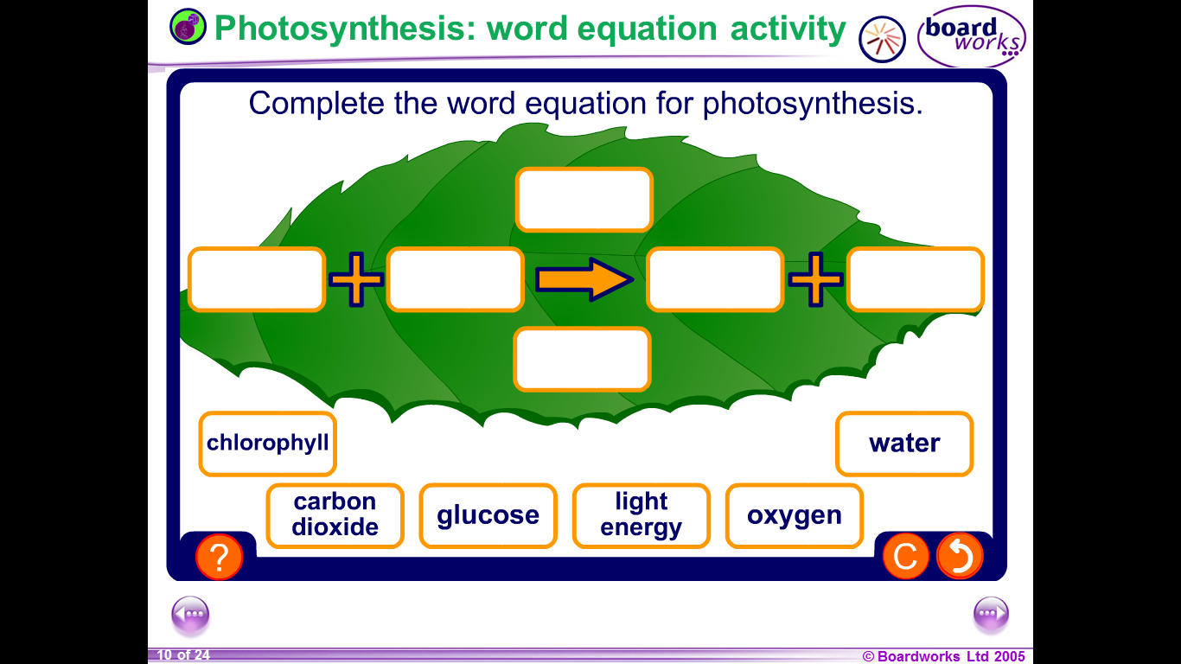

**Extension Tasks (Optional)**

Photosynthesis – Create a poster describing photosynthesis in a plant, the structure of leaves and the importance of minerals and fertilisers.