**Pure and Impure Booklet**

**To be completed week beginning 27th April**

This booklet covers:

1. Pure and Impure Substances
2. Dissolving Solutions
3. Factors Affecting Solubility
4. Separating Mixtures
5. **Pure and Impure Substances**

Chemists define the term ‘pure’ as a chemical that is natural. This is a substance that is made up on one type of atom. If there is more than one type of atom, then that substance is called ‘impure’.

For example, a glass containing just water is pure. But if you add anything to it, even if it dissolves, like salt, it is now impure. The extra substances added are called impurities.

Which of these diagrams shows a pure substance and which one is an impure substance?

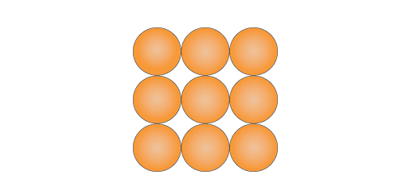

This particle diagrams shows a pure substance. There is only one type of atom. (Atoms are shown as circles)

This particle diagrams shows an impure substance because there are two types of atoms.



Substances can be given a rating to show how pure or impure they are. The most common example is gold:

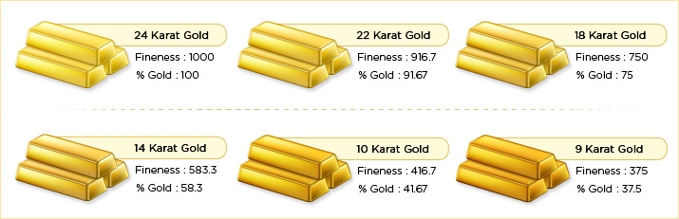

Substances can be tested to find out how pure or impure they are. The most common ways of doing this are to test melting points, boiling points or density. The more impurities that are added to the substance, the more the melting point, boiling point or density will change.

E.g. if you add salt to ice (like on roads in the winter) then the melting point is lowered which causes the ice to melt into water.

Impure substances are more commonly called mixtures. The different chemicals in the mixture can be separated without doing a chemical reaction.

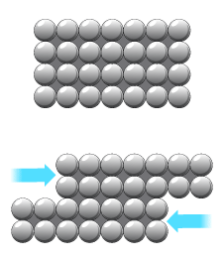Chemists often combine pure samples in fixed combinations in order to create new and useful mixtures. A good example of this is the development of metal alloys. This is mixing different metals together to make the metal stronger.

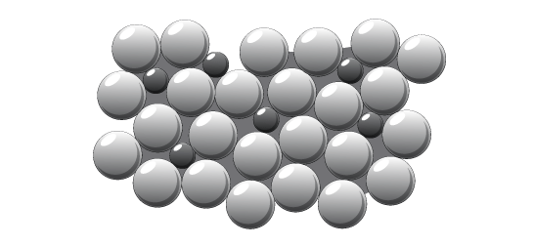

If different atoms are added there is now an irregular pattern. This means the atoms can’t slide past each other so the alloy (mixture of metals) is harder.

These layers can easily slide over each other. This means the metals are malleable.

Pure metals contain only one type of atom which form regular layers.

**Questions:**

1. What is the difference between a pure and impure substance?
2. What is the name of a substance added to a pure substance to make it impure?
3. How can you test to see if a substance is pure?
4. Why are some alloys stronger than pure metals?
5. **Dissolving Solutions**

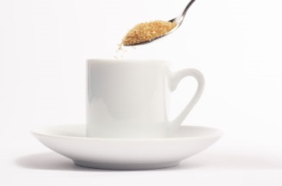What happens to sugar as you stir it into tea? It disappears but it has not gone – you can still taste the sugar. The sugar has been dissolved. This is a physical change (it can be reversed). This means that by evaporating the tea away, the sugar will be left behind.

There are lots of key terms in this topic:

* Solute – solid part of the mixture e.g. sugar
* Solvent – liquid part of the solution e.g. tea
* Solution – the combined solvent and solute e.g the cup of tea with sugar

**Melting or dissolving?**

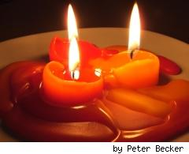Dissolving requires two materials to be mixed together. Melting is the result of one material being heated.

These candles are turning from a solid into a liquid. They are melting because they are not being added to a different liquid. There is only one substance (candle wax).

**More key terms:**

Soluble – a solid that can be dissolved into a liquid – e.g. salt (into water)

Insoluble – a solid that cannot be dissolved into a liquid – e.g. sand (into water)

Miscible – two liquids that can mix together (like dissolving, but with two liquids) – eg squash and water.

Immiscible – two liquids that cannot mix together – e.g. oil and water.

No matter how much you shake or stir water and oil they keep separating and will not stay mixed together.

**Conservation of mass** – when you mix two liquids, or dissolve a solid into a liquid, there are not any particles lost. This means the total mass of your solution will be the same as adding the two masses you had to start with. E.g. if you dissolve 10g of salt into 500g of water, the total mass of the solution will be 510g.

**Questions:**

1. Sea water is a mixture of salt dissolved into water. What is the solute, the solvent and the solution?
2. What word describes a solid that does not dissolve?
3. If sugar is dissolved into water, can you get the sugar back out again?
4. If alcohol and water are miscible, what does this mean?
5. **Factors Affecting Solubility**

Dissolving, like most things, can be done better by some chemicals than others.

Water is an excellent solvent that dissolves many different things. Some substances dissolve in water better than others. You will notice that some substances do not dissolve at all, such as sand, whereas others do dissolve, but it is difficult to make it happen.

Another factor that affects solubility in water is temperature. The higher the temperature of water, the more solute will dissolve.

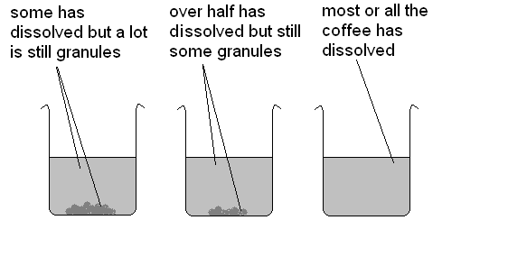So, warmer water can dissolve more sugar than cold water can. If you dissolve as much sugar as possible into warm water then put the solution outside it will cool down. As it cools down, some sugar will stop being dissolved and you will be able to see it at the bottom of the container. You can also see this with coffee:

Hot water

Warm water

Cold water

Gases do the opposite to solids when they are being dissolved. More gases can be dissolved in cold liquids than hot liquids. This means that if you put a fizzy drink outside on a warm day, it will go flat quicker than if you keep it cold. The gas that makes the bubbles in a fizzy drink is coming out of the solution, and will do this quicker when the drink is warmer compared to cooler.

**Questions:**

1. Is water very good or very bad at dissolving solids?
2. What can you do to increase the amount of salt that will dissolve into water?
3. Will a hot liquid be able to dissolve more carbon dioxide (a gas) or less than a cold liquid?
4. Will more life be able to live in ponds where the water is 40°C or 30°C? Why?
5. **Separating Mixtures**

There are 7 key techniques that can be used to separate out different mixtures:

* Filtration

**Remember**:

A mixture is 2 or more solids, liquids or gases that are combined together, but can be separated. Depending on which combination of solids, liquids or gases you have, depends on which technique you will need to use.

* Chromatography
* Evaporation
* Magnetism
* Freezing
* Melting
* Distillation

**Filtration** – We use filtration when we want to separate particles of insoluble solids from a solvent (liquid). The particles get stuck in the filter paper, and the solvent passes through.

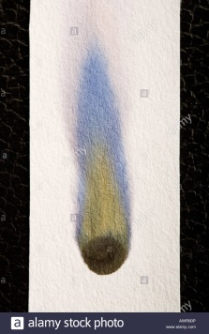

**Chromatography** - Chromatography can be used to separate coloured liquids. This is useful when assessing the purity some liquids. For example, is a black felt tip pen actually made out of black? If you put a dot of black ink onto some chromatography paper (which is similar to filter paper) then the different inks that make up black ink will separate out.

Chromatography separates dyes because dye particles dissolve and travel along the chromatography paper.

**Evaporation** – we can separate a soluble solid that has dissolved into a solvent by heat up the whole solution. The solvent will evaporate, leaving behind the solute. E.g. If a salt water solution is heated up, then the water will evaporate and the salt will be left behind.

**Magnetism** – if two solids are mixed together and one is magnetic but the other is not, they can be separated. E.g. Iron powder and sulfur powder (a yellow solid) can be separated because the iron is magnetic but the sulfur is not. The iron will be attracted towards any magnet that is put close to it, leaving the sulfur behind.

**Freezing** - Different liquids freeze at different temperatures. The liquid with highest melting point freezes first, so this can be separated. Example: Mixture of water and ethanol (alcohol). Ethanol freezes at -114°C and water at 0°C. So as you cool the mixture down, the water will freeze first leaving the ethanol as a liquid. The solid ice can be easily removed.

**Melting** - The solid with the lowest melting point melts first and so this can be separated. E.g. Alloys are made of different metals, as each metal melts, it is poured off into a container.

**Distillation** – this is used to separate liquids that have a different boiling temperature. You heat the mixture of liquids and as they heat up they will boil. One liquid will boil before the other and turn into a gas. It travels up the round bottomed flask, down the condenser tube where it turns back into a liquid. It is then collected as a pure liquid at the other end. See the diagram below:

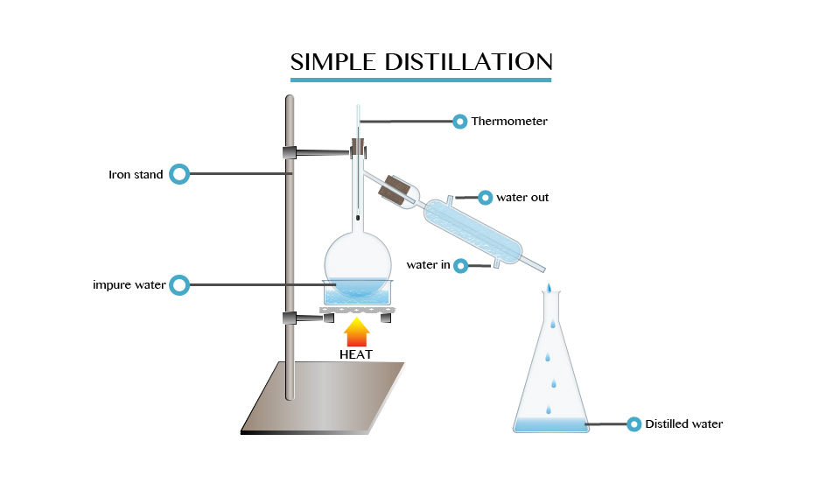

**Questions:**

1. Which separating techniques could be used to separate a mixture of two solids?
2. What needs to be different about the liquids in a mixture for distillation to work?
3. What does the condenser tube do in distillation?
4. Which technique would I use to find out which pen had been used by a criminal?
5. How would I separate a mixture of sand and water? Where will the sand be at the end?

**Answers:**

1. Pure substances have only one type of atom, impure substances have more than one type of atom.
2. Impurity.
3. Measure the melting point, boiling point or density and compare it to the value it should be.
4. The atoms do not form regular layers so they cannot slide over each other.
5. Solute is salt, solvent is water, solution is sea water.
6. Insoluble.
7. Yes, because dissolving is a physical process.
8. They can be mixed together and they will stay mixed (they will not separate).
9. Very good (it can dissolve lots of different solids).
10. Heat the water up.
11. Hot liquids can dissolve less gas than cold liquids.
12. Less life at 40°C because less oxygen can dissolve into the water and all living creatures need oxygen to survive.
13. Magnetism and melting.
14. They must have a different boiling point.
15. It turns the gas back into a liquid.
16. Chromatography.
17. Use filtration. The sand will be in the filter paper.