**Simple Chemical Reactions Booklet**

This booklet covers:

1. Observing chemical change
2. Atoms and Molecules in reactions
3. Testing gases
4. Writing chemical equations
5. **Observing chemical change**

What is a chemical reaction?

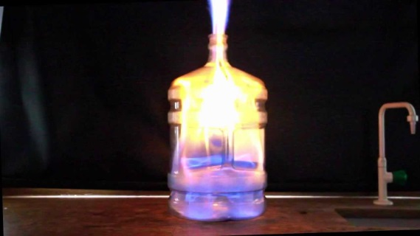

* Chemical reactions result in the formation of a new substance.
* Most chemical changes cannot be reversed. The exceptions involve another chemical reaction.
* It is important to know the difference between a chemical and a physical change.
* Physical changes are reversible.
* All changes of state are physical changes. Melting and boiling are physical changes.

For example, changing ice to water to steam can be reversed.

**Recognising a chemical reaction has happened:**

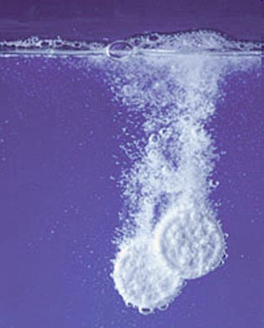

|  |  |  |  |
| --- | --- | --- | --- |
| 1. Bubbles or fizzing (correct science word if effervescence). This shows a gas being released. E.g. a substance is used up | Are Indian cars rust proof |  | 2. A colour change – a new substance has been made, e.g. rust. |
|  | science chemistry precipitation reaction lead iodide | Fundamental ...  4. A temperature change – either increase or decrease.  3. Precipitate become visible – this is a solid made when two liquids react. |  | Hotter Stock Photos and Images. 505 Hotter pictures and royalty ... |

**Reactants and products:**

Iron + oxygen 🡪 iron oxide

Reactants 🡪 Products

Chemicals that react together are reactants, the substance or substances formed are called products. Always put an arrow between the two (never use an equals sign). Some reactions are faster than others, we can measure chemical changes by measuring volume or monitoring temperature.

Questions:

1. What is a chemical reaction?
2. Write a word equation for the reaction between magnesium and oxygen.
3. List 4 ways of recognising a chemical reaction.
4. Complete the following table:

|  |  |  |
| --- | --- | --- |
| ***Experiment*** | ***Reversible or***  ***Irreversible?*** | ***Physical or chemical change?*** |
| Ice cube melting |  |  |
| Kettle boiling |  |  |
| Bunsen burner on |  |  |
| Burning toast |  |  |
| Dissolving salt in water |  |  |
| Boiled egg |  |  |
| Magnesium dropped in acid |  |  |
| Burning splint |  |  |
| Dissolving tablets in water |  |  |
| Baked cake |  |  |

1. **Atoms and molecules in reactions**

**What is a Compound?**

When two or more elements are joined together we can make a compound.

Examples:

Sodium Chloride(salt) is made up of Sodium and Chlorine.

Hydrogen oxide(water) is made up of Hydrogen and Oxygen.

Carbon dioxide is made up of Carbon and Oxygen.

Iron Oxide(rust) is made up of iron and Oxygen.

When chemical reactions take place, the atoms in the reactants become arranged differently to form the products.

When two elements react together to form a compound, atoms of the elements combine.

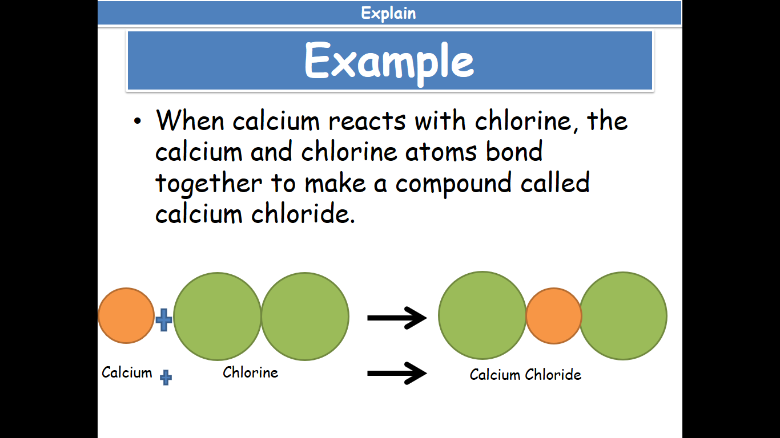The number of atoms in the reactants and products are the same and therefore mass has stayed the same.

When two compounds react, new bonds are formed and the atoms are rearranged.

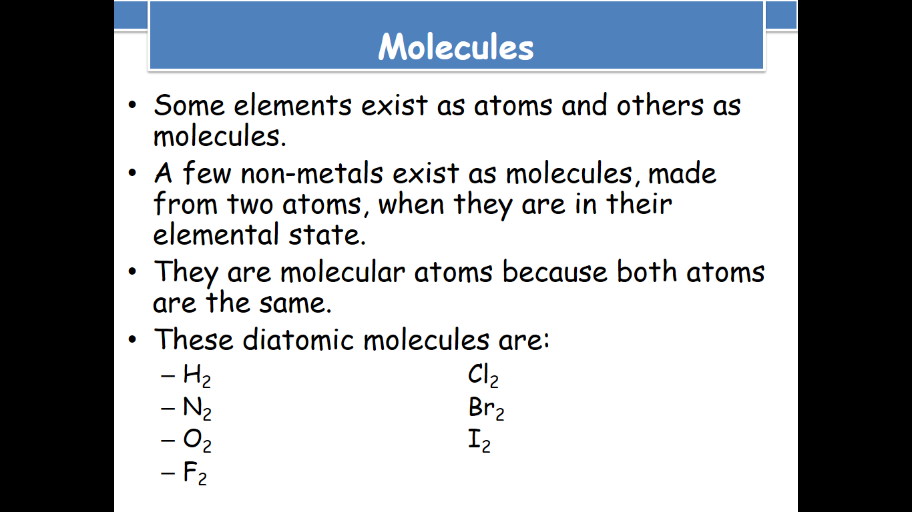

**Burning Fuels**

**What happens in reactions when we burn fuels?**

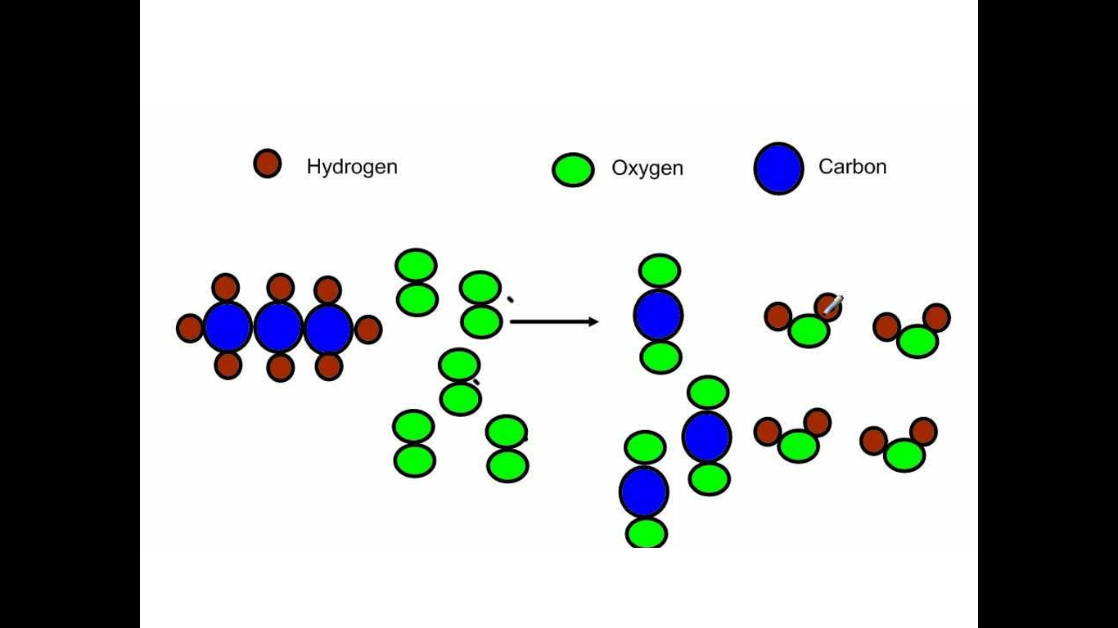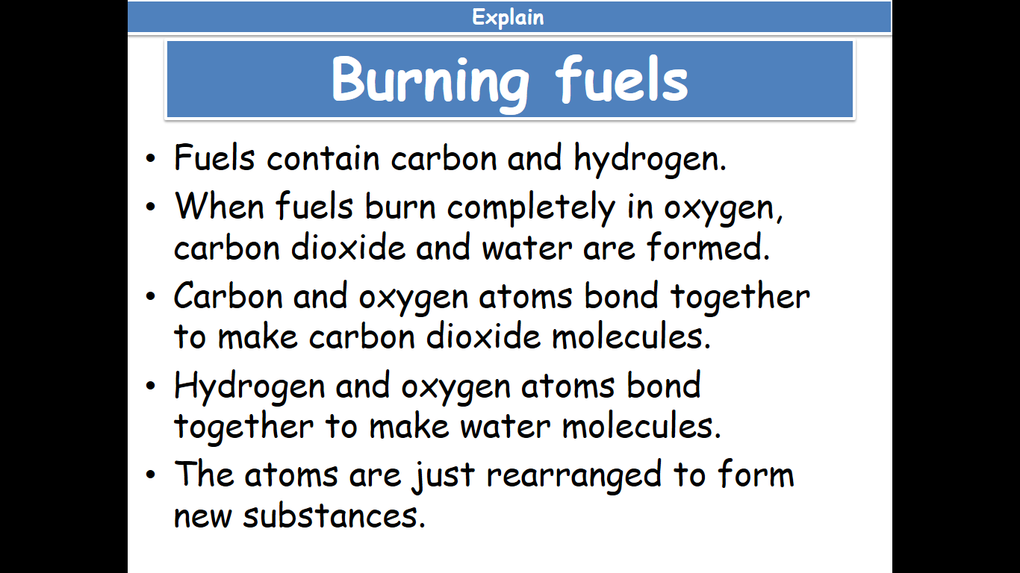

**Complete or incomplete Combustion?**

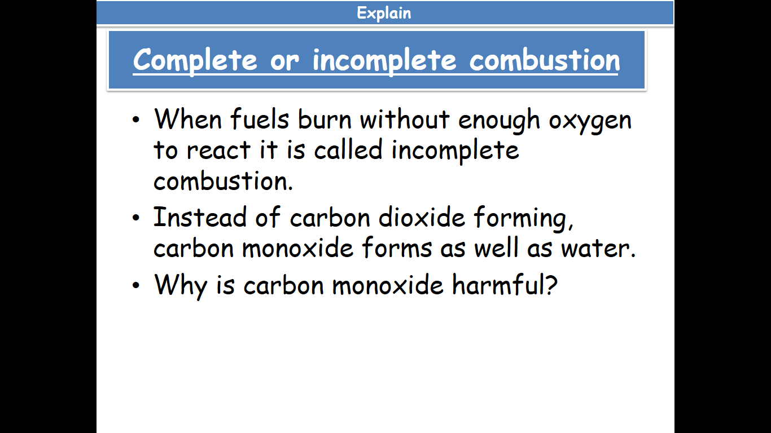

Questions:

5. Which atoms make up a) Calcium Chloride b) Copper Oxide c) Hydrochloric acid?

6. Name 4 examples of diatomic molecules

7. What happens to the bond in hydrochloric acid when it reacts with sodium hydroxide?

8. What would you see if the arrangement of atoms led to a gas being produced?

9. Which bonds need to be broken, for hydrogen to react with oxygen? Which bonds are made?

1. **Testing gases**

In order to identify the gas produced in a reaction it must first be collected.

How do we collect gases?

Look at the diagrams and read the paragraph.

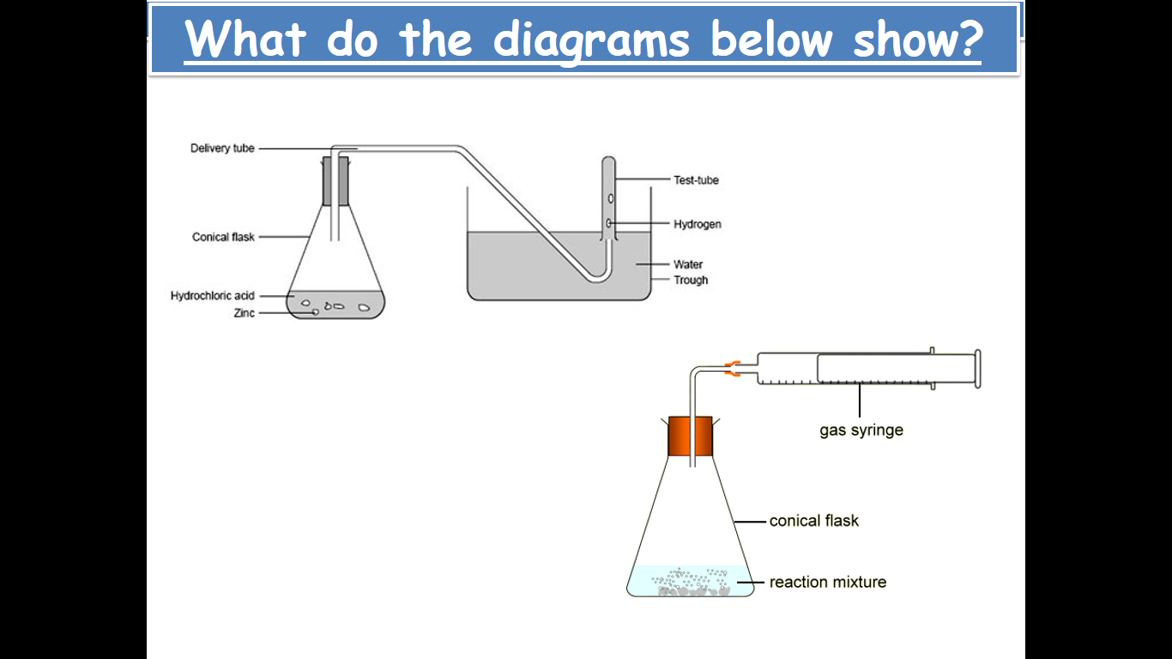

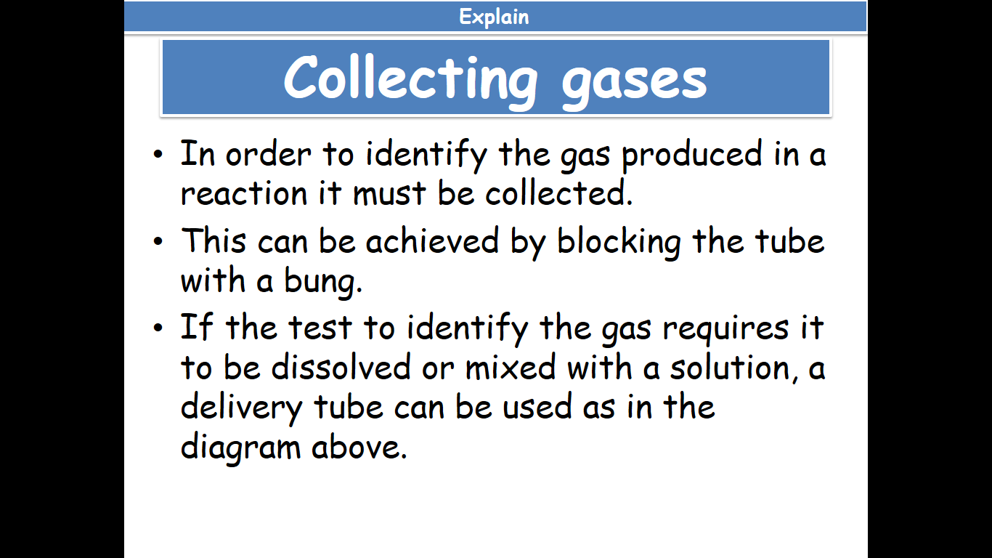

**Testing** **gases**

Once a gas is collected, chemists can set about testing the gas that has been made. Usually they have an idea about which gas will be produced and so can choose the tests which are most appropriate. They can choose from bubbling the gas through another solution or testing with damp litmus paper or using a lit or glowing splint. Gases can be acidic, alkaline or neutral.

There are several gases that can be tested for easily in the laboratory. These include: Hydrogen, Oxygen, Chlorine, Carbon dioxide, Sulfur dioxide, Ammonia and Water Vapour.

To test for **Carbon dioxide**

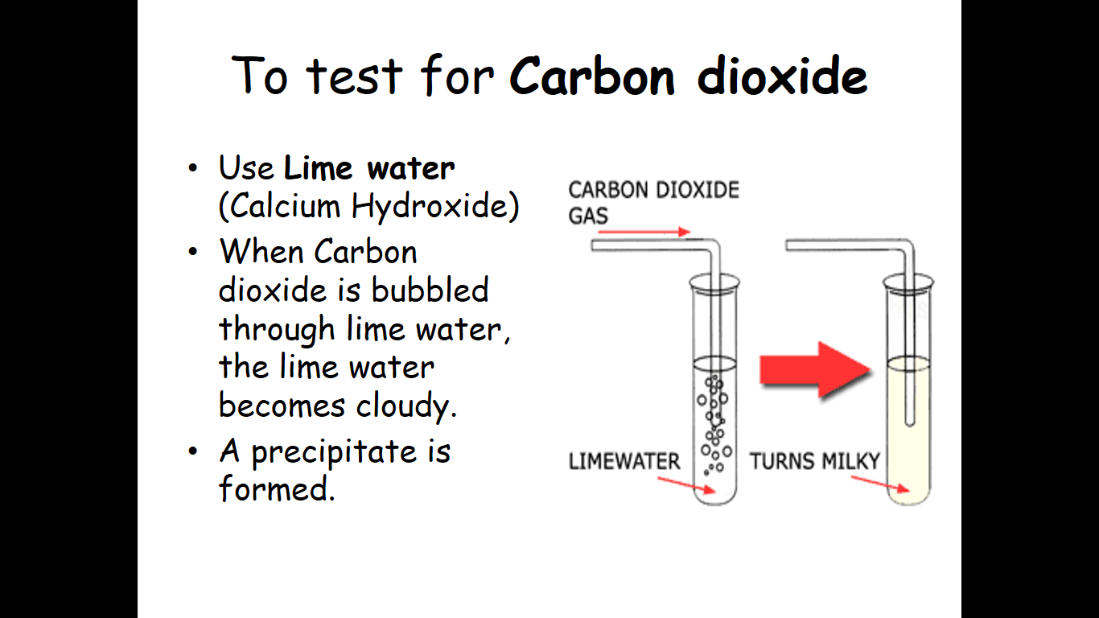

To test for **Hydrogen**

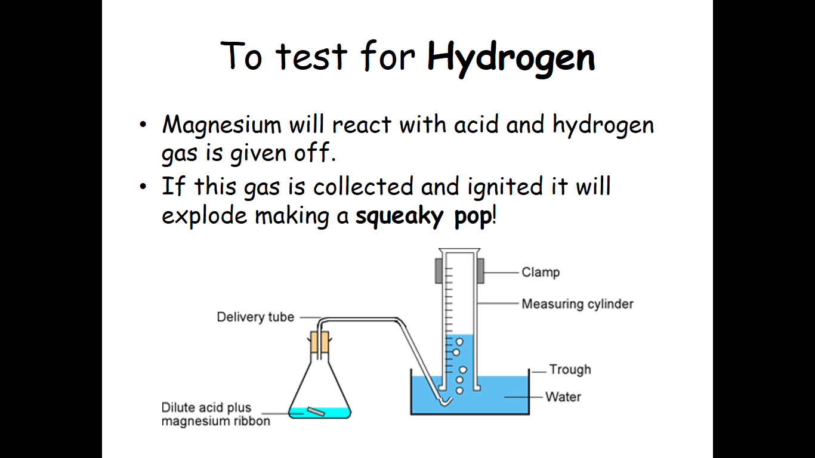

To test for **Oxygen**

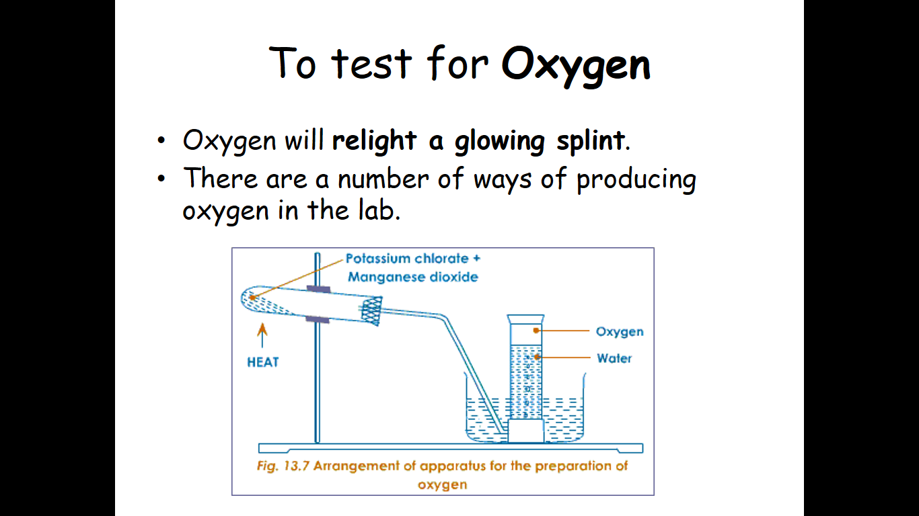

To test for **Chlorine**

Add bleach and Hydrochloric acid together in the same test tube and warm the test tube in your hand. Hold some damp blue litmus paper at the neck of the test tube – If Chlorine is present the paper will turn red and then bleach (go white).

Questions:

10. What is the difference in testing for oxygen and hydrogen?

11. Which gases are neutral?

12. How could you identify a gas you have collected in a gas syringe?

13. Choose the correct gas collection method (collect over water/ bubble through test solution/collect in gas syringe) for the following situations:

a) Quick identification

b) To know the volume and then identify the gas

c) To find the volume of a gas you know to be soluble in water.

1. **Writing chemical equations**

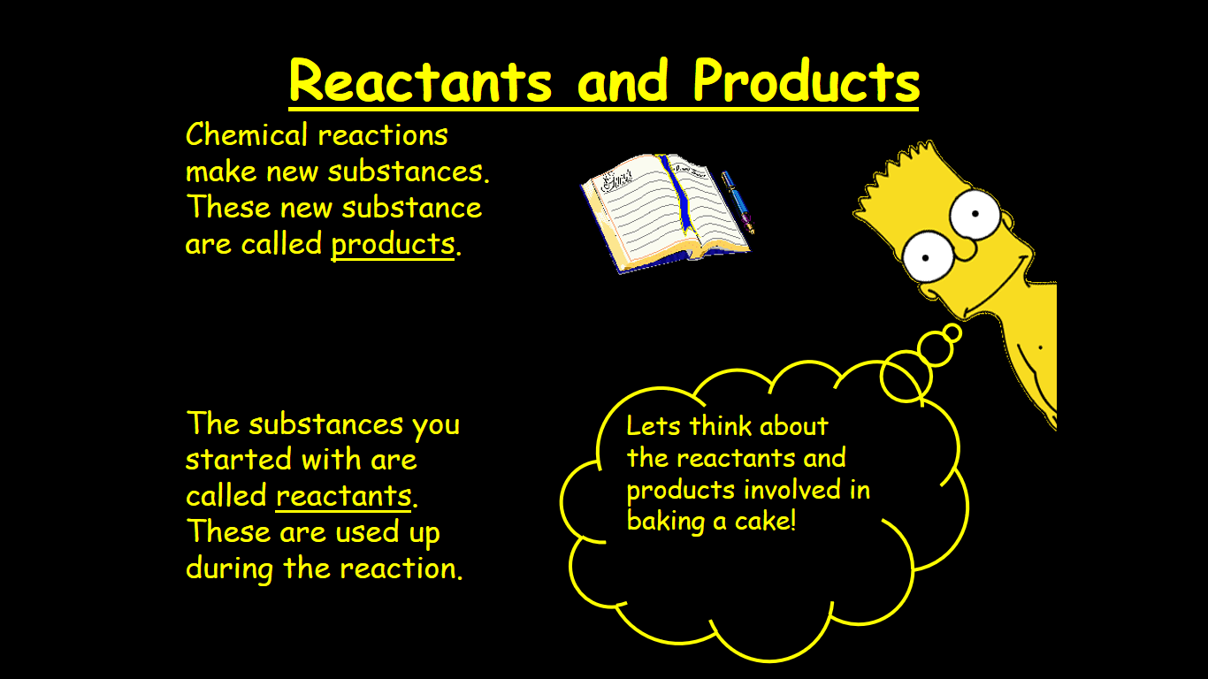 .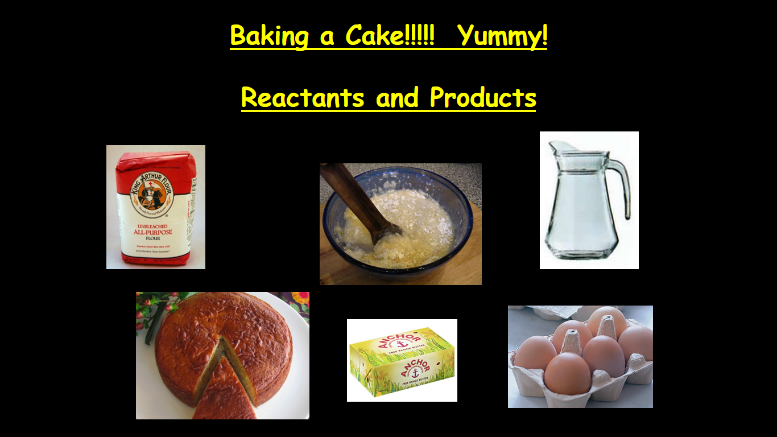

Writing an equation for baking a cake, it might look like this:

FLOUR + BUTTER + EGGS + MILK 🡪 CAKE

So, how about a chemical reaction between Zinc and copper sulphate to form zinc sulphate and copper.

Word equation:

Zinc + Copper sulphate 🡪 Zinc sulphate + Copper

Reactants 🡪 Products

The starting chemicals are called Reactants.

The chemicals that are made (produced) are called Products.

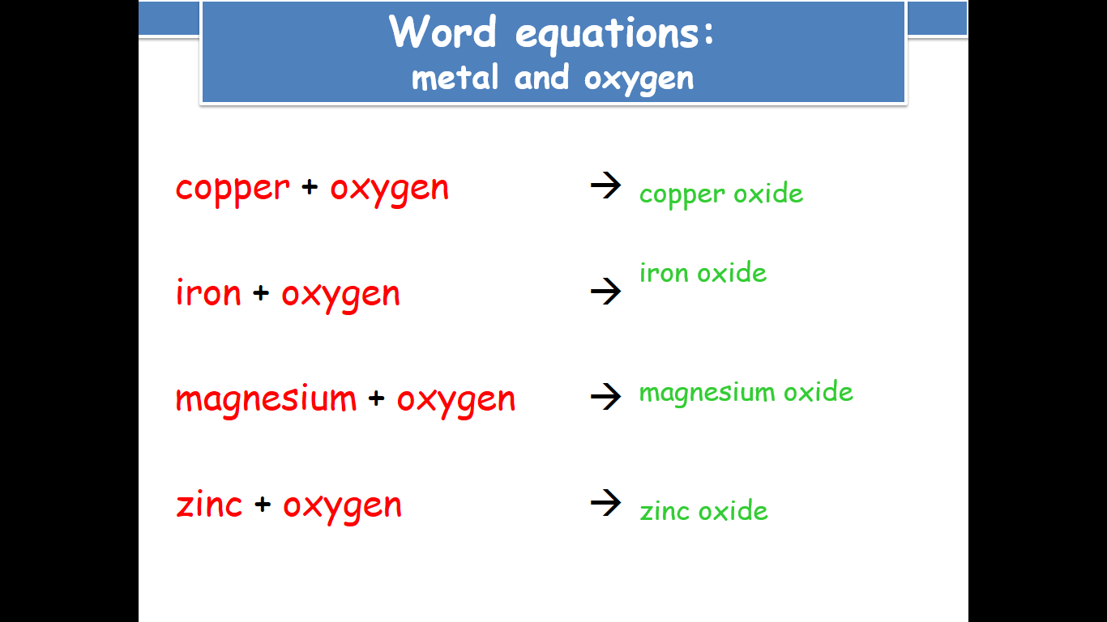

**What about symbol equations?**

You can use your periodic tables to find the symbols for elements involved. When writing a symbol, the first letter of a symbol will always be a capital letter and the others will be lower case.

You can learn symbols for common compounds such as carbon dioxide and water. Just remember for numbers like ‘2’ in carbon dioxide must be written slightly below the letters: CO2. Similarly, water is H2O.

**Balancing Equations**

This simply means you have to have the same number of each type of atom before and after the reaction has taken place.

To make equations balance, numbers may have to be added in front of one or more of the symbols for the reactants and products.

**What exactly does this mean?**

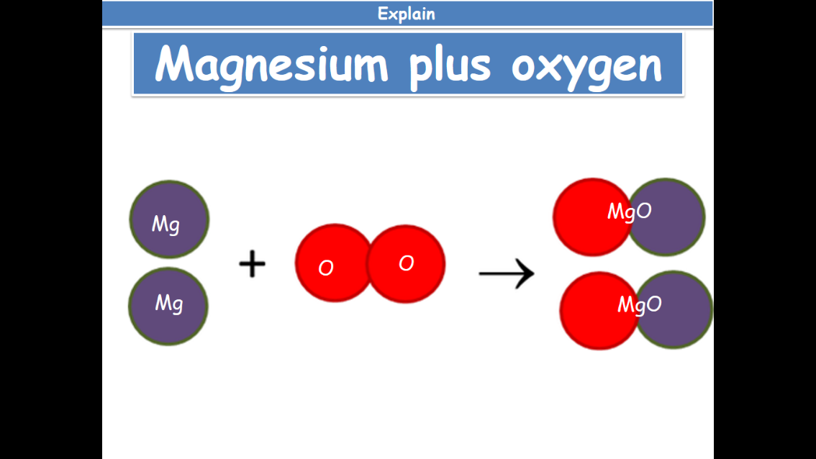

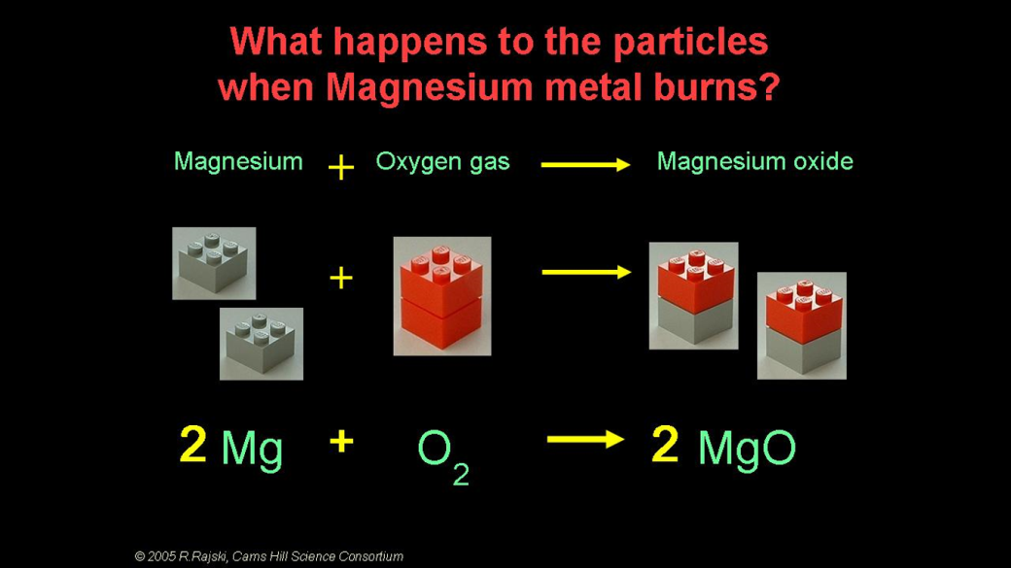Here is another example:

Questions:

14. Find the symbols for the following elements: Potassium, Cobalt, Zinc, Bromine, Carbon, Copper, Iron, Calcium

15. Write down the formula for the following common Compounds: Sodium Chloride, Hydrochloric acid, Sodium hydroxide, Sulphuric acid, Copper Sulphate, Ammonia.

Are the following equations balanced?

16. CaCO3 🡪CaO + CO2

|  |  |  |  |
| --- | --- | --- | --- |
| Atom Type | Left hand side | Right hand side | Balanced? |
| Ca |  |  |  |
| C |  |  |  |
| O |  |  |  |

17. H2O2 🡪 H2O + O2

|  |  |  |  |
| --- | --- | --- | --- |
| Atom type | Left hand side | Right hand side | Balanced? |
| H |  |  |  |
| O |  |  |  |

18. Na + Cl2 🡪 NaCl

|  |  |  |  |
| --- | --- | --- | --- |
| Atom type | Left hand side | Right hand side | Balanced? |
|  |  |  |  |
|  |  |  |  |

19. Mg + HCl 🡪 MgCl2  + H2

|  |  |  |  |
| --- | --- | --- | --- |
| Atom type | Left hand side | Right hand side | Balanced? |
|  |  |  |  |
|  |  |  |  |
|  |  |  |  |

**Extension Task**

Simple chemical reactions – Create an information sheet showing the difference between chemical and physical reactions, what happens to atoms and molecules in reactions and how we can test for the gases: carbon dioxide, hydrogen and oxygen.