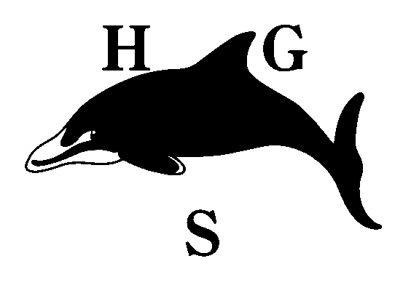
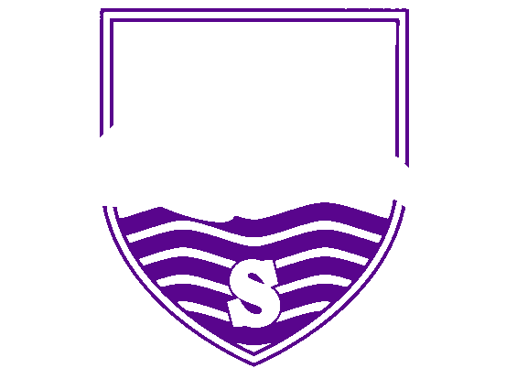
Hall Green School
An Academy

Year 11 GCSE Update – 8th January 2021

To all Yr 11 pupils, parents and carers

As you will have heard in the news, the Government has decided that this summer’s GCSE exams will not be going ahead as normal due to the ongoing pandemic. I know you will all be frustrated not to be able to take the final GCSE exams you have been working towards and you will be uncertain as to how you will be graded and what type assessments you might be asked to complete. I hope this update will help alleviate some of that uncertainty.

At present, the exact process by which GCSE grades will be awarded this summer has not yet been shared with schools, but as soon as we know more I will let you know immediately. However, it is likely that when you return to school you will need to take internal exams or assessments in most of your subjects and possibly external assessments in some of your subjects. The results of these assessments will contribute towards determining your final GCSE/BTEC grade.

Therefore, it is vital that you continue to work hard throughout this lockdown, both attending live lessons through MS Teams, completing all work set through ClassCharts and maintaining a revision programme using the resources made available by your teachers and online providers such as MyMaths. As I said in the video uploaded to the front page of the school website this week, you should continue to work as though your exams were going ahead this summer. This will mean that when you return to school after half term (or when the Government determines Year 11 can return to school) you will perform to the best of your ability in the assessments that you take.

I know that some pupils will understandably be worried that their final GCSE results may now be based solely on last October’s mock exams. We can assure you that this will not be the case. Mock exams results are nearly always lower than pupils’ final outcomes and we understand that as your teachers.

We expect to be basing our decisions on a range of evidence and your professional predictions are a better guide to how you are currently performing. Your next set of professional predictions will be sent home as part of your report on or just after 21st January. These predictions will show the grades we currently think you would be most likely to achieve if the exams were being held this summer. There is still plenty of time to improve upon these grades through well planned revision and hard work and this should be your focus for the next 6 weeks. Our departments are very experienced at making the right grading decisions and we make sure that these are based on a range of evidence. Please do not email your teachers asking for higher grades to be predicted - I have asked your teachers not to reply to these requests.

Finally, I am very sorry that you are having to spend further time out of the classroom during your last year at school. However, the remote lessons and support we are putting in place will give you every chance of success this summer if you work hard during this period of lockdown.

Best wishes, stay safe and I’m looking forward to seeing you all soon.

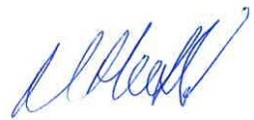

Mr M Hosfield

Hall Green School is a company limited by guarantee. Registered in England & Wales. Registered Number 7892732.
Registered Office: Southam Road, Hall Green, Birmingham B28 0AA Headteacher: Miss K Slater Tel: 0121 628 8787
Fax: 0121 702 2182 Email: enquiry@hallgreen.bham.sch.uk www.hallgreen.bham.sch.uk

