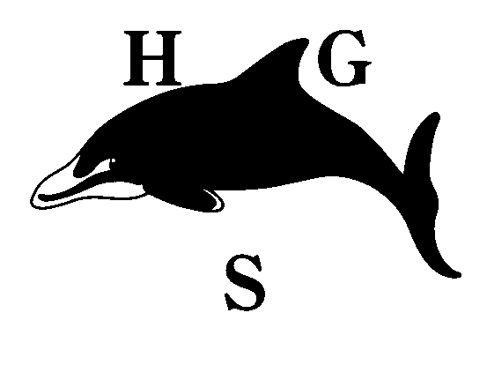
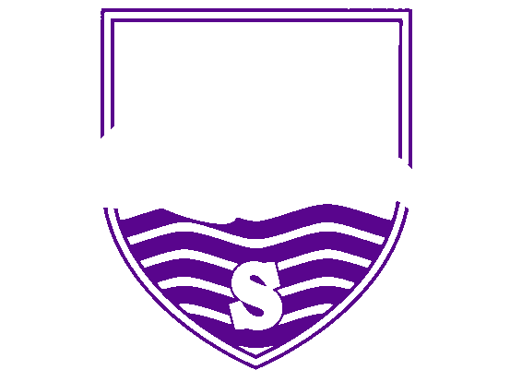
Hall Green School
An Academy

GCSE Update: 1.3.21

Dear Year 11 Pupil and Parent/Carer

I want to let you know further information about the awarding of GCSE and Vocational Qualifications this summer following Ofqual’s recent announcement, which you can read here.

Whilst more detail will follow, it is clear that a significant part of your final grade in each of your subjects will be based on the 'final assessments' taken in school when Year 11 return. These final assessments will only be set on work that will have been covered during your KS4 and will almost certainly take place in classrooms rather than the hall. Additional evidence may be used to determine your overall grade, but good performance in the final assessments is the best way for you to secure good grades in the summer.

It is really important that you continue to work towards these final assessments and treat them like the 'normal GCSE exams' in terms of revision and preparation. The exam boards will let us know which and how many topics we will need to cover and this will help focus your final revision programmes. However, it's really important that you continue to revise NOW and don't wait for exam boards to tell you exactly what to cover - that information may still be a few weeks away and the work you are currently doing will not be wasted.

Your revision should be focusing on revision notes (I like the Cornell notes template), mind maps, flash cards and lots of self-testing. There are apps such as Seneca Learning and Pearson Revise that set short answer questions that are marked for you by the app – and these are great ways for checking where you have gaps in knowledge. Revision sessions should be 45 minutes long and at this stage of Year 11, pupils should be aiming for at least ten 45-minute revision sessions a week, on top of their lessons and homework. I would also recommend using exam board resources, including checking you have covered everything you need to in the syllabus and using past papers to give you exam practice at home.

In terms of a time frame, I think your final assessments are likely to be in May, but there will be other assessments before then that could contribute towards your final grades. Keep working hard and you will give yourself the best chance of success. As soon as we know more we will let you know what you can expect, but for now, I've attached a leaflet that helps further explain this year's GCSE process that you can access here.

Could I also take this opportunity to flag up the importance of completing all college and apprenticeship applications as quickly as possible. I know that most of Year 11 have applied to their preferred destinations, but if you haven’t then I would strive to get applications in by the end of this week. If you need any extra support with your applications then please contact Miss Homer at school
Finally, I want to wish you the best of luck over the next few weeks and months. As ever, you will experience ups and downs along the way, but with a strong revision programme I know you can do well and I hope we are celebrating a great set of results on August 12th with our 2021 Year 11.

Yours faithfully
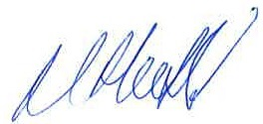

Mr M T Hosfield

Hall Green School is a company limited by guarantee. Registered in England & Wales. Registered Number 7892732.
Registered Office: Southam Road, Hall Green, Birmingham B28 0AA Headteacher: Miss K Slater Tel: 0121 628 8787
Fax: 0121 702 2182 Email: enquiry@hallgreen.bham.sch.uk www.hallgreen.bham.sch.uk

