Support for your child at Hall Green School

An Academy

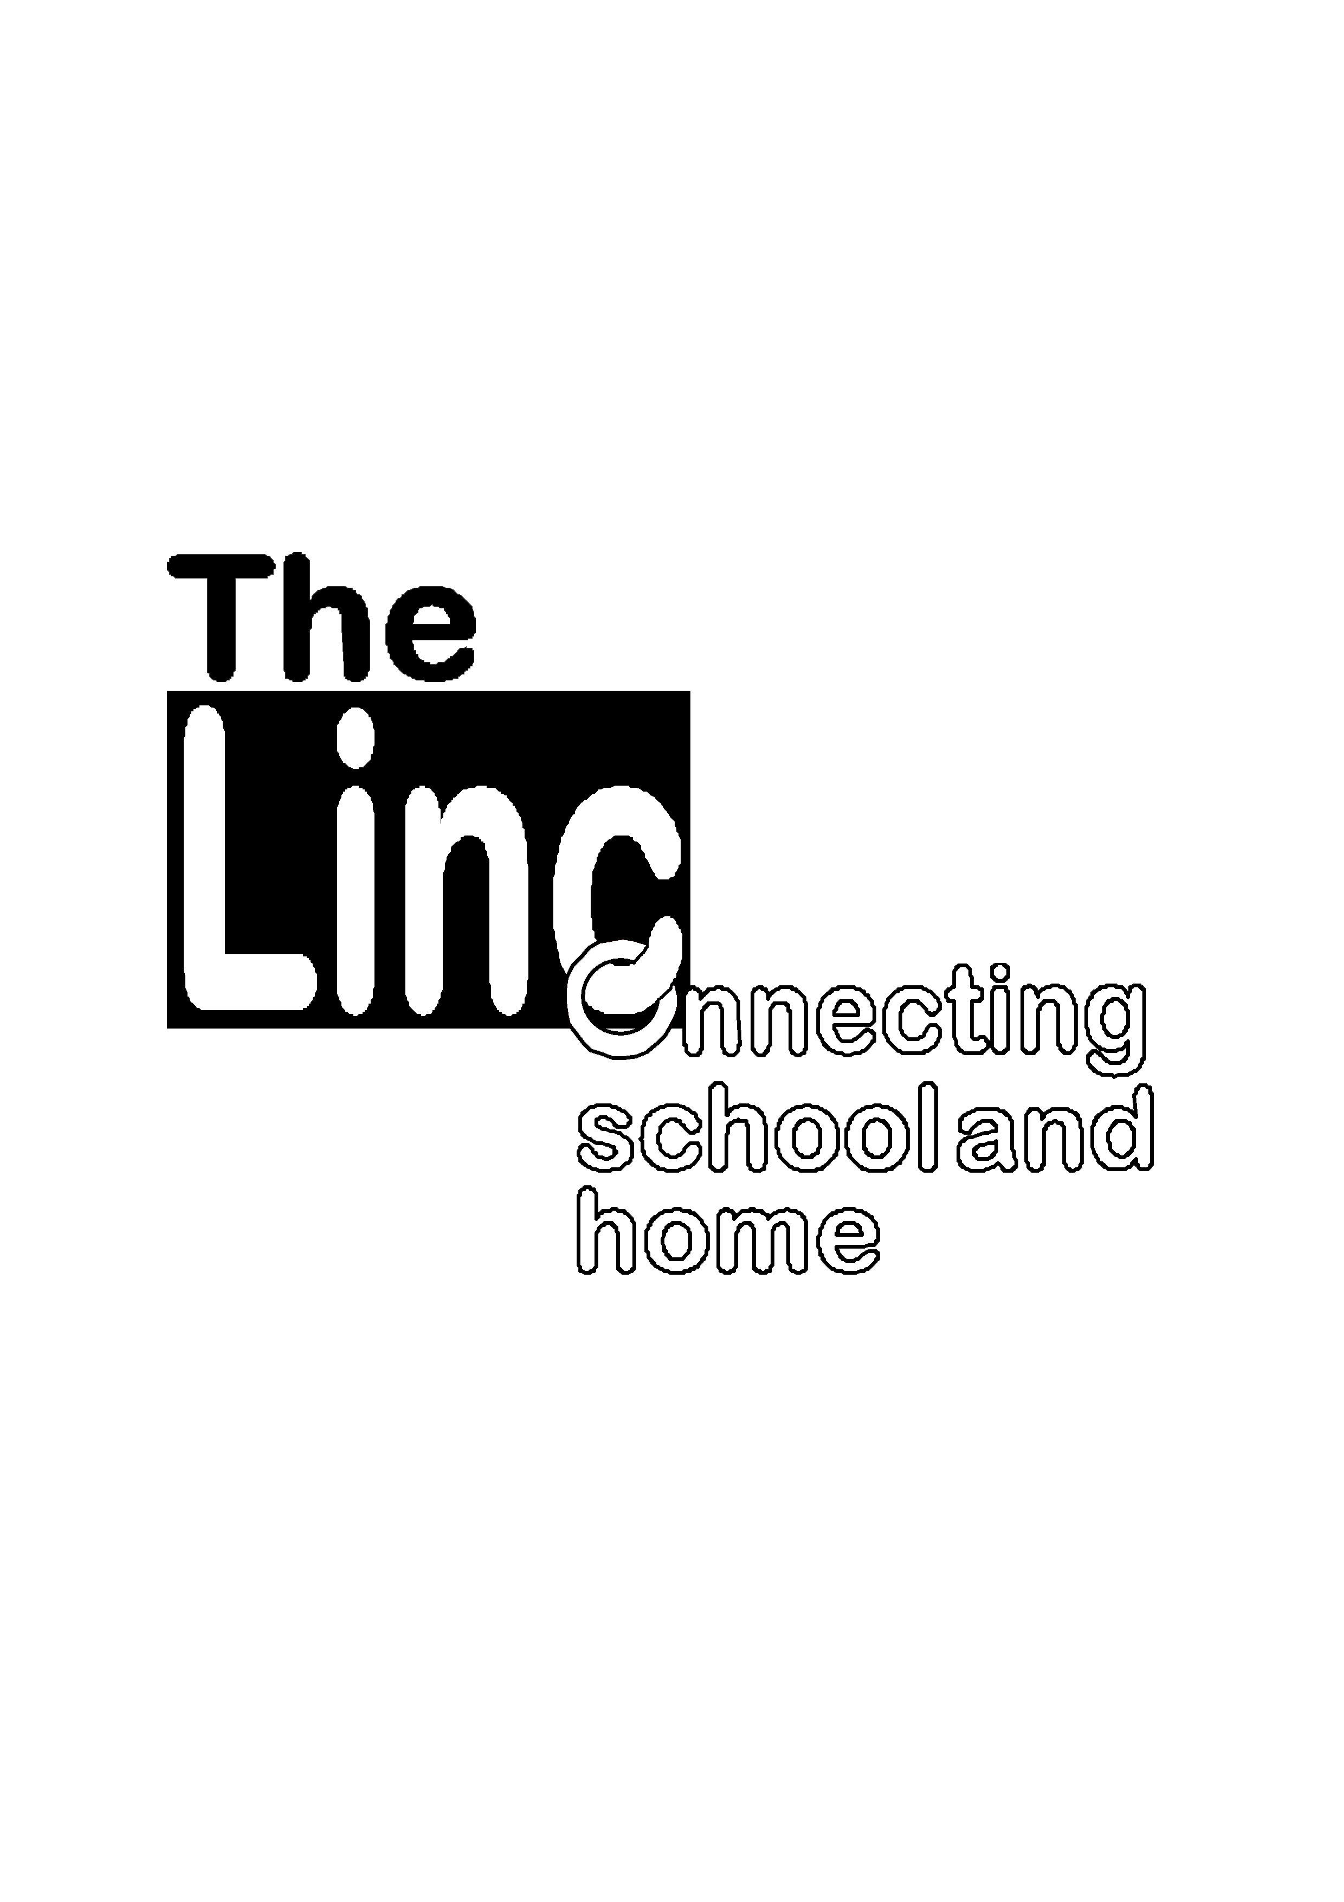

Our job is to help your child achieve the very best they can at school. You know your child best and you may feel that they need some additional support for some or all of their time a school.

This information is to inform you of the types of support available for your child at Hall Green School. It will help you understand who can help and how this support can be accessed.

HGS is a Fully Accessible Mainstream (FAM) School. This means if your child has a Physical Disability he/she will be able to access all areas of the school as we have:

* 4 Lifts (including one for access to the performance stage)
* Ramps
* Automatic doors
* Disabled toilets
* Teaching assistants to assist with personal care

Parents whose child has an EHCP and are for wishing their child to attend the FAM School, do this via consultation with SENAR when their child is in Year 5 of primary school. The SENCo at the primary school will assist with this process. Parents are welcome to contact the SENCo at HGS to arrange a tour of the school before making their final decision.

All pupils in school receive high quality first teaching. This means that a range of teaching and learning styles are used and that appropriate learning objectives are set for all children with a curriculum matched to their needs.

Most of our classes are supported by teaching assistants and pupils may also be offered small group work or catch up programmes where needed, such as Fresh Start.

Some children also need support at the beginning of the day, at break and/or at lunchtime – our RightStart, T2E and The Hub, support small numbers of children who need different provision at these busy times; support can also be arranged so our extracurricular activities are inclusive.

At HGS, the progress and attainment of all pupils is reviewed at points of ‘data returns’ by the subject teachers and SENCo, at which time provision may be adjusted to meet identified needs.

You would normally be informed about your child’s general progress and targets through Individual tracking sheets, an annual report, Parents Evenings and Academic Tutorials.

If a child continues to have difficulty after intervention or has a high level of difficulty when they join us, they may be considered to have special educational needs (SEN) and be placed on the SEN Register.

Children with SEND have learning difficulties and/or physical disabilities which make it harder for them to learn than most children of the same age. They will need extra support or different help e.g, modified tasks, extra time or breaks for formal assessments, a reader, a scribe or specialist equipment.

Schools and other agencies can help most children overcome their difficulties quickly and easily but a few children will need extra help for some or all of their time in school.

This means they may have difficulty with:

* Some or all of the work in school
* Reading, writing or mathematics
* Understanding information
* Expressing themselves
* Understanding others
* Organising themselves
* Sensory perception or physical mobility
* Managing their behaviour
* Making friends or relating to adults

At HGS every effort is taken to ensure transition times are successfully managed. Additional visits are arranged for pupils transferring from Year 6-7 and pupils who are moving to college at Year 11. These are to re-assure you and your child about the changes.

SEND

(Special Educational Needs and Disability)

The Special Educational Needs and Disability code of Practice: 0-25 years gives guidance to schools in meeting the needs of pupils. It sets out how help should be given in a step-by-step approach. You will be consulted at all stages of this graduated approach and staff will inform you of the additional work they do with your child.

Subject teachers will assess your child to identify their strengths, needs and the extra help they require. If they need extra or different support than most children their age, the SENCo will place them on the SEN Register at:

**SEN Support (K)**

* Extra help from a teaching assistant in class
* Small group support
* Alternative resources such as a sloping board, ICT access, visual prompts, a task card

If your child continues to have difficulty even with this extra support, we will seek professional advice from:

* Pupil and School Support Services
* Physical Disability Support Services
* Sensory (visual/hearing) Support services
* Health professionals

We have a highly experienced team of staff who may be involved in supporting your child at HGS. These include:

* Your child’s **subject teacher**, who will always make sure that tasks set are appropriate and accessible for your child.
* **The SENCo** **(Mrs Mac)** who co-ordinates all the provision of SEND in school [c.mac@hallgreen.bham.sch.uk](mailto:c.mac@hallgreen.bham.sch.uk) 01216288787
* **Assistant to the SENCo (Mrs Griffiths) –** supports the day to day running of the department
* **Teaching Assistants**, who support all pupils in class
* Our **Pastoral Team** who can advise upon whether your child would benefit from further support or assessment.
* Our **Welfare and Inclusion Manager** may give advice or complete any assessments for a few children.
* Our **School Nurse** who works closely with us and can advise and assess any medical needs. If a care plan is required this would be done in conjunction with the parent/nurse and reviewed annually at minimum.
* One of the **School Governors** who works with the SENCo in leading SEN in school

To ensure our staff has the skills and knowledge to support children with SEND – there is a programme of on-going training in both school and elsewhere. Recent training has included Autism Awareness and Deaf Awareness.

Educational Health Care Plans (EHCPs)

From September 2014, all children and young people from age 0-25, who have significant special educational needs will undergo an Educational Health and Care assessment (unless their parents, carers or the young person opt out of the new system). This will lead to an EHCP.

If you would like to know what provision is in place for your child or if you have any concerns that your child has some additional needs, please speak to their subject teacher, Head of House or form tutor who can put a plan in place to support your child.

You are also very welcome to make an appointment with our SENCo

Mrs Mac

0121 628 8787

[c.mac@hallgreen.bham.sch.uk](mailto:c.mac@hallgreen.bham.sch.uk)

At HGS we value support and feedback from all our stakeholders. We have an active School Learning Council and conduct pupil voice activities throughout the year.

If you want advice from professionals outside of school you may find the following number and website helpful:

Birmingham SEN Parent Partnership: 0121 303 5004

Birmingham children and Family Services: [www.birmingham.gov.uk/childrenservices](http://www.birmingham.gov.uk/childrenservices)

