Hall Green School
An Academy
June 2021

Dear Parent/Carer,

Transfer to Hall Green School

Welcome to the Hall Green School family!

We are delighted your child will be joining us and are very much looking forward to meeting them and the wider family.

At Hall Green School we are proud of our track record of combining high academic standards and successful outcomes for all pupils within a warm and caring atmosphere. We are a school that serves its local area, a true comprehensive that reflects the diversity and the richness of the community. As a fully accessible school, Hall Green has inclusion and diversity at the heart of all that it does. Our values are encapsulated in the school mission statement, ‘Learning Together, Shaping the Future.’

In line with Birmingham Public Health and council guidance, our virtual induction day and processes will be completed virtually this year for the majority of pupils. We have arrangements in place for those with special educational needs or additional vulnerabilities to support their specific transition needs. If you do not hear directly from us and feel your child falls into this category, please do contact us.

More details regarding the online transition programme will be shared in due course.

You should already have received communication from us about Summer School, which we are still hoping will be able to run, please contact the school office on Tel: 0121 628 8787 or email us at enquiry@hallgreen.bham.sch.uk if you have any queries.

Within this pack you will find the immediate information required prior to your child starting. All our school policies and further information about the school can be found on our website (https://www.hallgreen.bham.sch.uk/policies/) which I would encourage you to read and share with your child. To ensure a smooth transition to the school, it is essential you return the following completed forms to school immediately or by the latest Wednesday 23 June:

- Admission form e) Canteen cashless system
- Medical form f) Instrument tuition
- Home-School agreement g) School Trips
- Free School Meals application form
Term starts for Year 7 pupils on Friday 3 September 2021. We will be in touch nearer the time with more details.

Yours faithfully,
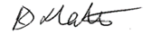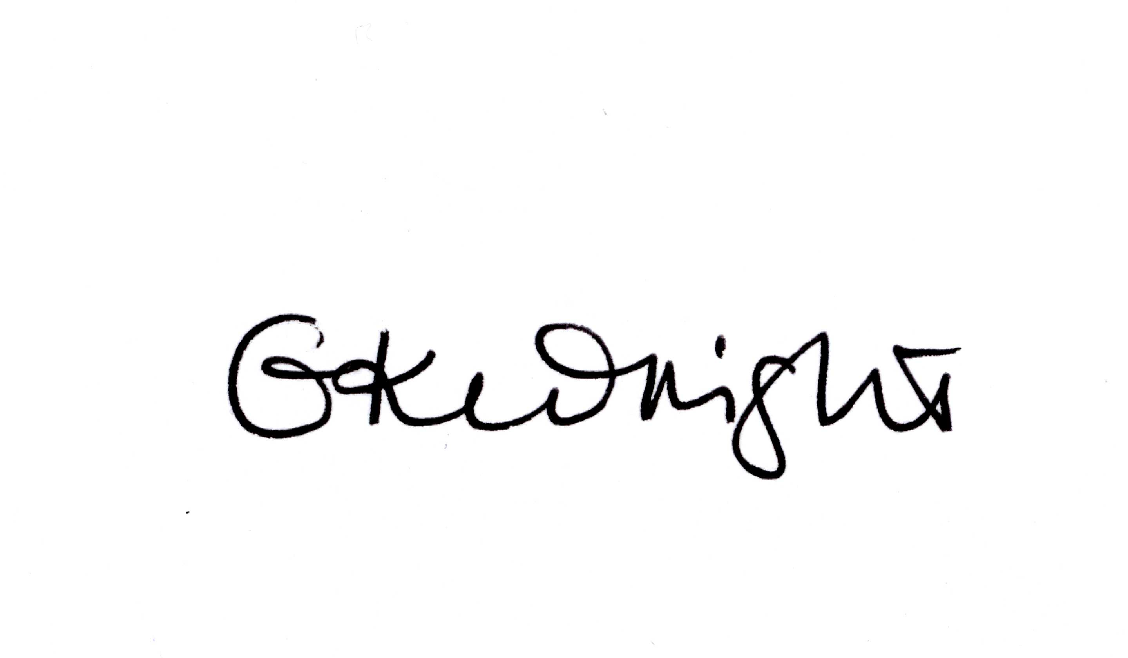
Miss K Slater Ms G Wright
Headteacher Head of Shire House/Transition Leader

Free School Meals
If you believe your child is entitled to Free School Meals can you please complete the enclosed application form and return to the School Office no later than Friday 9 July 2021. Please also try to provide a recent copy of proof of entitlement as detailed in the application form that must not be dated before 2 March 2021.

Dress Code
You will find our Dress Code within this pack. Please do note, particularly if you have had other children attend the school, we have recently reviewed and revised the code. This is to ensure it is as affordable as possible whilst maintaining our high standards. Support is available if needed; please contact the school office.

Behaviour policy
We pride ourselves on our high standards that are reflected throughout our school. This ensures our pupils achieve excellent outcomes and leave Hall Green School as successful, responsible, and respectful young adults.
- https://www.hallgreen.bham.sch.uk/wp-content/uploads/2021/05/HGS-Positive-Behaviour-For-Learning-Policy.pdf

Mobile Phones
Pupils are allowed to bring mobile phones to school but they must be turned off and out of sight throughout school. Pupils may listen to music through in ear headphones when outside at break and lunch time if they desire although their phone should remain out of sight.

Educational Visits/Trips
You will find a separate consent form for trips in your pack. It is vital that this it completed and returned in order for your child to access the full curriculum.

School Fund
We have a school fund which receives income from a variety of sources – sponsorship, fund raising by pupils and parents/friends of the school. We also invite all families to contribute to this at the start of their school life with us through a one off £20.00 per child contribution, to cover the five years of attendance at Hall Green School. If you feel you are able to make a larger contribution it would be gratefully received. Our School Fund helps to pay for the cost of things which the education budget does not meet, but which help to support various pupil activities throughout the year and to make school life more enjoyable. Although we realise that School Fund is a voluntary contribution, it does enable us to provide additional resources to enhance the curriculum ad your support is very much appreciated. We use a secure website called ParentPay to make payments. You will receive the details of this in due course.

Attendance
We place a huge importance on pupils attending school. Please refer to the enclosed leaflet from Birmingham City Council’s Attendance Team for more details. Our term dates for 2021/22 can be found on our website: https://www.hallgreen.bham.sch.uk/term-dates/

School Day
We are currently reviewing the structure of our school day following changes that were made due to the pandemic. Confirmed details of our school day from September will be shared nearer the time.

Photographic consent
Celebrating successes and sharing news of our work in school is important to us. For this reason, within the Admission Form you are asked for consent for photographs and videos of your child to be used. There are two ways in which we use images:
- Within school on notice boards and in school magazines, brochures, newsletters, etc.
- Outside of school by external agencies such as the school photographer, newspapers, campaigns and online on our school website or social media pages.
Please be assured that everything published is controlled and edited as necessary in line with our GDPR policy. If you at any point decide to change your decision, please contact the school office.

E-Safety and Acceptable Use Policy
Access to the school network will be provided for your child to carry out recognised school work only, but only on the understanding they agree to the guidelines set out in the E-Safety and Acceptable Use policies:
- https://www.hallgreen.bham.sch.uk/wp-content/uploads/2021/05/HGS-E-Safety-Policy.pdf
- https://www.hallgreen.bham.sch.uk/wp-content/uploads/2021/05/HGS-Guidelines-for-Pupil-Users-of-the-School-Network.pdf
Each time they sign in to the network, they will be asked to confirm they agree to follow the guidelines.

Medicines in School
It is vital we have up to date medical information at all times. The enclosed medical form must be completed and returned. Parents/carers must always inform the school if anything changes from the information previously shared.
- https://www.hallgreen.bham.sch.uk/wp-content/uploads/2021/05/HGS-Medicines-in-School-Policy.pdf
Hall Green School also works closely with NHS Birmingham to ensure that your child is fully up to date with his or her vaccines. They have asked us to pass this message on to parents:
When all children move to secondary school, they will be learning and socialising with a larger number of children and staff than they have been used to at Junior School, and so could be at risk of catching preventable diseases if they haven’t had all their childhood jabs.
If you are not sure if your child has had all their routine vaccinations, check their personal health record (Red Book) or contact the GP surgery.
To get the best protection for your child, they need to have had two does of MMR vaccine. For a checklist of the vaccines and the ages at which they should ideally be given visit www.nhs.uk/vaccinations

Data Protection
General Data Protection Regulation (GDPR) and The Data Protection Act 2018 (DPA) is the law that protects personal privacy and upholds individual’s rights. It applies to anyone who handles or has access to people’s personal data. Our policy is intended to ensure that personal information is dealt with properly and securely and in accordance with the legislation. It will apply to personal information regardless of the way it is used, recorded and stored and whether it is held in paper files or electronically. Hall Green School as the Data Controller will comply with its obligations under the GDPR and DPA. The school is committed to being concise, clear and transparent about how it obtains and uses personal information and will ensure data subjects are aware of their rights under the legislation.
https://www.hallgreen.bham.sch.uk/wp-content/uploads/2021/05/HGS-Data-Protection-Policy-1.pdf

Hall Green School is a company limited by guarantee. Registered in England & Wales. Registered Number 7892732.
Registered Office: Southam Road, Hall Green, Birmingham B28 0AA Headteacher: Miss K Slater Tel: 0121 628 8787
Fax: 0121 702 2182 Email: enquiry@hallgreen.bham.sch.uk www.hallgreen.bham.sch.uk

