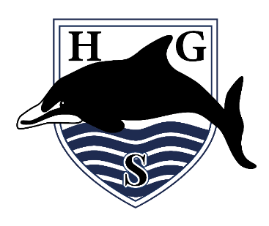
Hall Green School
An Academy

March 2023

Dear Parent/Carer

Science Trip to Natural History Museum, London on Thursday 22 June OR Tuesday 27 June 2023 (Year 10)

In order to support your child in their Science GCSE studies, we have arranged a visit to the Natural History Museum in London on either Thursday 22 June OR Tuesday 27 June. The date your child is attending will be detailed in ParentPay, when you make the payment. *Please note, there could be a mock exam on Thursday 22 June. If your child is due to go on this date and they are then involved in the mock exam, they will be moved to go on the trip on Tuesday 27 June*.

Although the trip is not compulsory, we strongly recommend that your child attends, as it will cover the topics of: Biology Unit - Natural Selection and Chemistry Unit - Earth and Atmosphere.

In order for the trip to take place we require a non-refundable payment of £23.95 to be made online via ParentPay by no later than Monday 24 April 2023. In exceptional circumstances, if you do not have access to the internet, please ask for a barcode to pay at a local shop that offers PayPoint. It is essential that all payment deadlines are adhered to; any students that have not paid by this date will not be permitted to participate in this trip. Deadlines are set to ensure the school can make payments to the organising company in advance of the trip taking place. Payment also signifies parental permission for the pupil to attend the trip. If your child is eligible for the Pupil Premium we may be able to help meet part of the cost of this trip. If financial help is required, please contact Mrs Dickerson via the usual school number. If your son/daughter does not attend the trip, they will be expected to be in school as usual on the day.

On the day of the trip, pupils are to arrive at school promptly at 7.30am and will travel by coach from Hall Green Library. We will return to Hall Green Library at approximately 5pm–5.30pm and pupils will be dismissed from there, unless you specify otherwise. Your child will require a pen, a packed lunch, a drink and snacks for the trip. If your child is entitled to a free school meal and you wish a lunch to be provided by school, please order this as soon as possible with your Science teacher. Pupils MUST wear school uniform and should bring a waterproof coat and wear comfortable shoes/trainers.

We will use the emergency contact details and medical records for your child that we currently hold on file. If there have been any recent changes to either of these, please could you inform the school office as soon as possible.

IMPORTANT: During trips and visits, members of the public often comment upon the good behaviour of our pupils and how they are ambassadors for our school. It is important to reiterate that if your child fails to meet the school’s Expectations for Learning, displays unacceptable behaviour (in or out of school) or shows a poor attitude towards staff, the privilege of attending may be revoked at any time at the Head Teacher’s discretion. If your child is removed for any of these reasons, no refund of any monies paid will be made.
Yours faithfully, Mrs Ziebeck (Science Department)

Hall Green School is a company limited by guarantee. Registered in England & Wales. Registered Number 7892732.
Registered Office: Southam Road, Hall Green, Birmingham B28 0AA Headteacher: Miss K Slater Tel: 0121 628 8787
Email: enquiry@hallgreen.bham.sch.uk www.hallgreen.bham.sch.uk Twitter @HallGreenSch

