FREE SCHOOL MEALS - Application Form  Please ensure that the titles and names provided on this application exactly match those held by Department for Work and Pensions, the Home Office and HMRC, any errors may result in your details not found and a declined decision being given. | 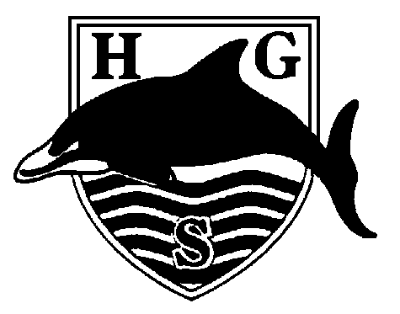

Pupils that attend Hall Green Secondary School.
Full Name | Sex | Date of Birth | Year Grp

You will qualify for free school meals if you or your partner receive:
- Income Support (IS);
- Income Based Jobseekers Allowance (IBJSA);
- Income Based Employment and Support Allowance (ESA).
- Support under part VI of the Immigration and Asylum Act 1999.
- Guaranteed element of State Pension Credit.
- Child Tax Credit, provided you do NOT get Working Tax Credit and have an annual income that does not exceed £16,190.
- Universal Credit – If the net earned family income in under £7400 per year.

If you’re not sure whether you receive one of the listed benefits, or what your household income is, but you would still like us to check whether your child is eligible for free school meals, please place an X in this box.

To apply please complete and return this form to the school office. We are now able to check your entitlement via a secure government website which links to your benefit providers. However if the Eligibility Checking Service has not been able to verify your entitlement, we will then need to contact you to ask for evidence (dated within the last 6 months) to show you are currently in receipt of one of the eligible benefits and payslips if applicable.
Your address | Post Code:
Contact Tel No |  |  |  |  | Email Address
We cannot process your application without this information. Please ensure it is completed in full and accurately.
Failure to provide this information may result in your application being declined.
Parent/Guardian Details |  | Parent / Guardian 1 |  |  |  |  | Parent / Guardian 2
Title |  | Mr Mrs Ms Miss |  |  |  |  | Mr Mrs Ms Miss
First Name
Surname
Date of Birth
   |  | / |  |  | /
   |  | / |  |  | /
National Insurance Number
School Office: Date…………..……..Reference 1………………..…………………………Reference 2………….………………………
Other children that are living with you
Full Name |  |  | Sex | Date of Birth |  | School Attends

We cannot backdate claims.
The date of entitlement is the date that we confirm your eligibility and successfully process your application.
Declaration: If you give false information you could be prosecuted
The information I have given on this form is complete and accurate. I understand that my personal information is held securely and will be used only for local authority purposes. I agree to the local authority using this information to process my application for free school meals. I also agree to notify the local authority in writing of any change in my family’s financial circumstances as set out in this form.

Your signature: | Date:

Thank you for completing this form - How the information in this form will be used
The information you provide in this form will be used by the Local Authority to confirm receipt of one of the listed welfare benefits.
The information will also be used in relation to pupils in year 3 or above to decide whether they are eligible for free school meals.
You only need to complete this form once and it will last for the duration of your child’s time at their current school.
We are committed to ensuring that the personal and sensitive information that we hold about you is protected and kept safe and secure, and we have measures in place to prevent the loss, misuse or alteration of your personal information. We will use the information you provide to assess entitlement to free school meals only.

This documentation is treated in accordance with
the General Data Protection Regulation (GDPR) (EU)2016/679

Office Use Only | Approved | Declined
Reference Number/s
Date
Decision Letter Sent (Date)
SIMS Updated

